String ProjectPath = System.getProperty(“user.dir”);

Exception can be handled.

Error can't be handled.

Throws will suppress the error and will not handle the error.

########################## 23rd Jan ############

import payroll.*; // payroll is package name

import payroll.Employee; // Only import the Eomplyee class

A class file can contain any number of import statements. The import statements must appear after the package statement and before the class declaration.

$$$$$$$$$$$$$$$$$$$$$Access Levels $$$$$$$$$$$$$$$$$$$$

Visible to package (default) Example : Class A

Visible to class only ( Private )

-Visible to the world (Public)

-Visible to package and Subclasses ( protected)

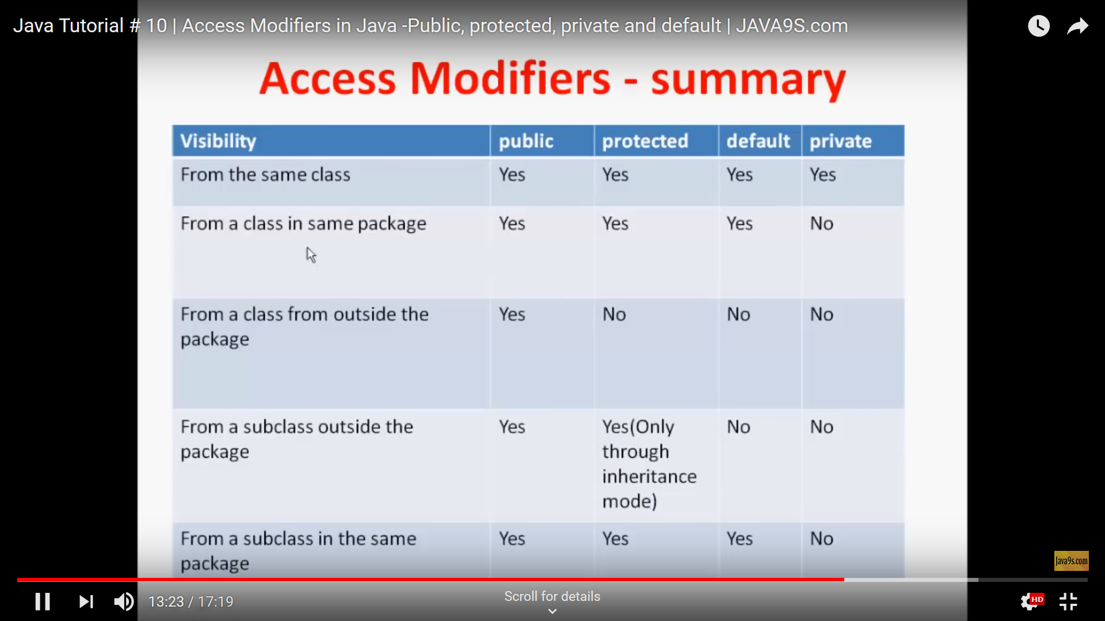

########################### Date 24th Jan 2019 ###################

Different block and their order of execution Java Class

* Static Block
* Init Block(Anonymous Block)
* Constructor

####################4th feb 2019 ############

You can have any number of main methods in a class by method overloading. But JVM calls main() method which receives string array as arguments only.

**class** TestOverloading4{

**public** **static** **void** main(String[] args){System.out.println("main with String[]");}

**public** **static** **void** main(String args){System.out.println("main with String");}

**public** **static** **void** main(){System.out.println("main without args");}  }

########################5th feb 2019 ################

**Java 8 Default Method in Interface**

Since Java 8, we can have method body in interface. But we need to make it default method. Let's see an example:

interface Drawable{

void draw();

default void msg()

{

System.out.println("default method");}

}

Since Java 8, we can have static method in interface. Let's see an example:

interface Drawable{

void draw();

static int cube(int x)

{

return x*x*x;}

}

class Rectangle implements Drawable

{

public void draw(){System.out.println("drawing rectangle");}

}

###################### 7th feb

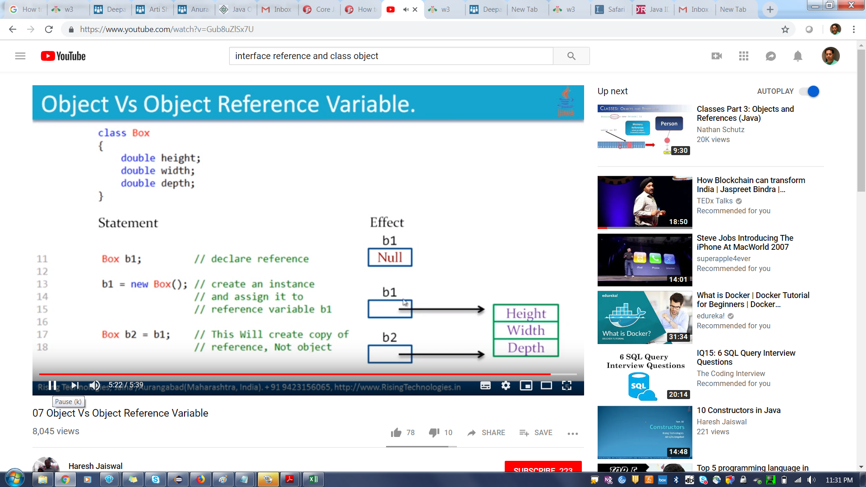

Polymerphism = Data hiding + Abstraction

Tightly encapsulated means all variable of the class must be private.

Class A

{

Private int a =10;

}

################## 13th feb 2019 ##############

Rules for Overriding.

YouTube Link for Overriding concept:

https://www.youtube.com/watch?v=MYzaDgNGmTg

Access Modifier visibility: Private ( Less )🡪Default 🡪 Protected --🡪 public ( Highest )

We can reduce the visibility or access of inherited method.

Case 1 : If parent class is Public, then inherit class method must be public.

Case 2 : if parent class method is protected, then inherit class method can be either protected/public.

Case 3 : if parent class method is default then inherit class method can be default/protected/public.

Case 4 : if parent class method is private then we can’t inherit private method. i.e Overriding concept is not applicable for private access modifier.



########################## 15th Feb 2019 #####################

Difference between super(),this() and super and this

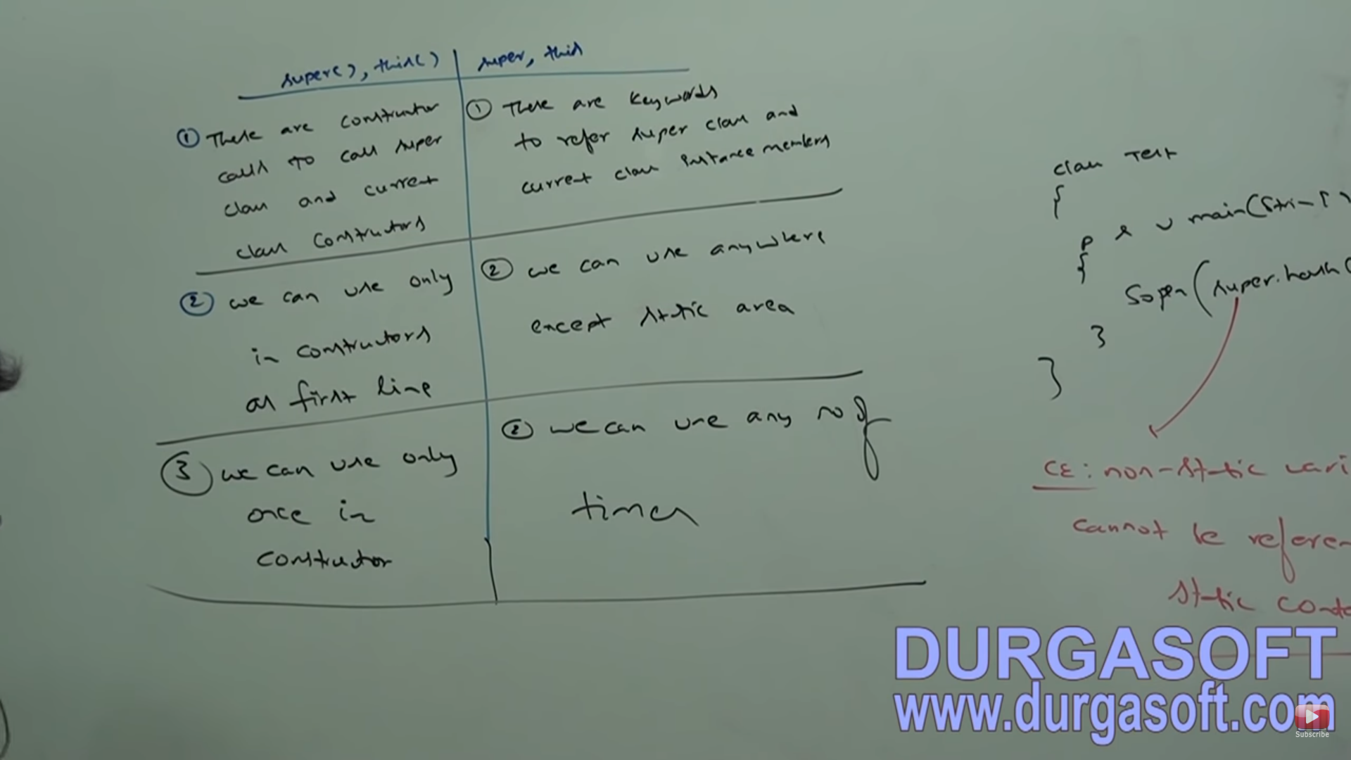

Recursive constructor example right side :

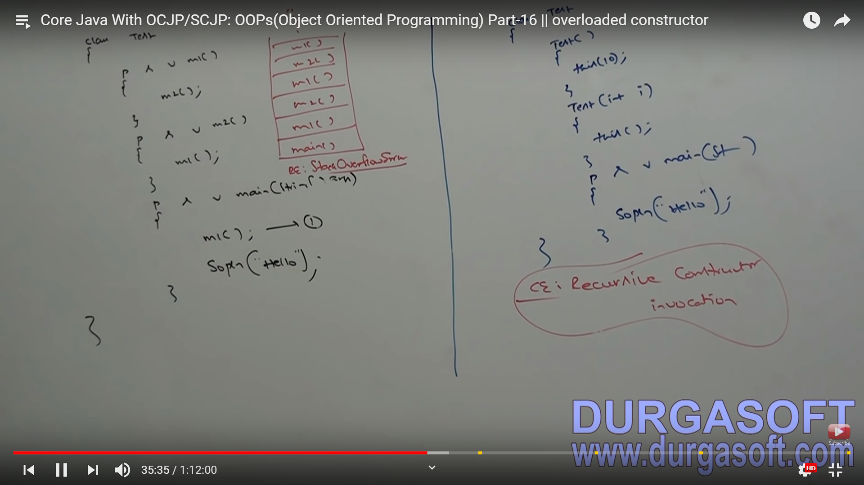

#################### 16th Feb 2019 Exception handling #########################

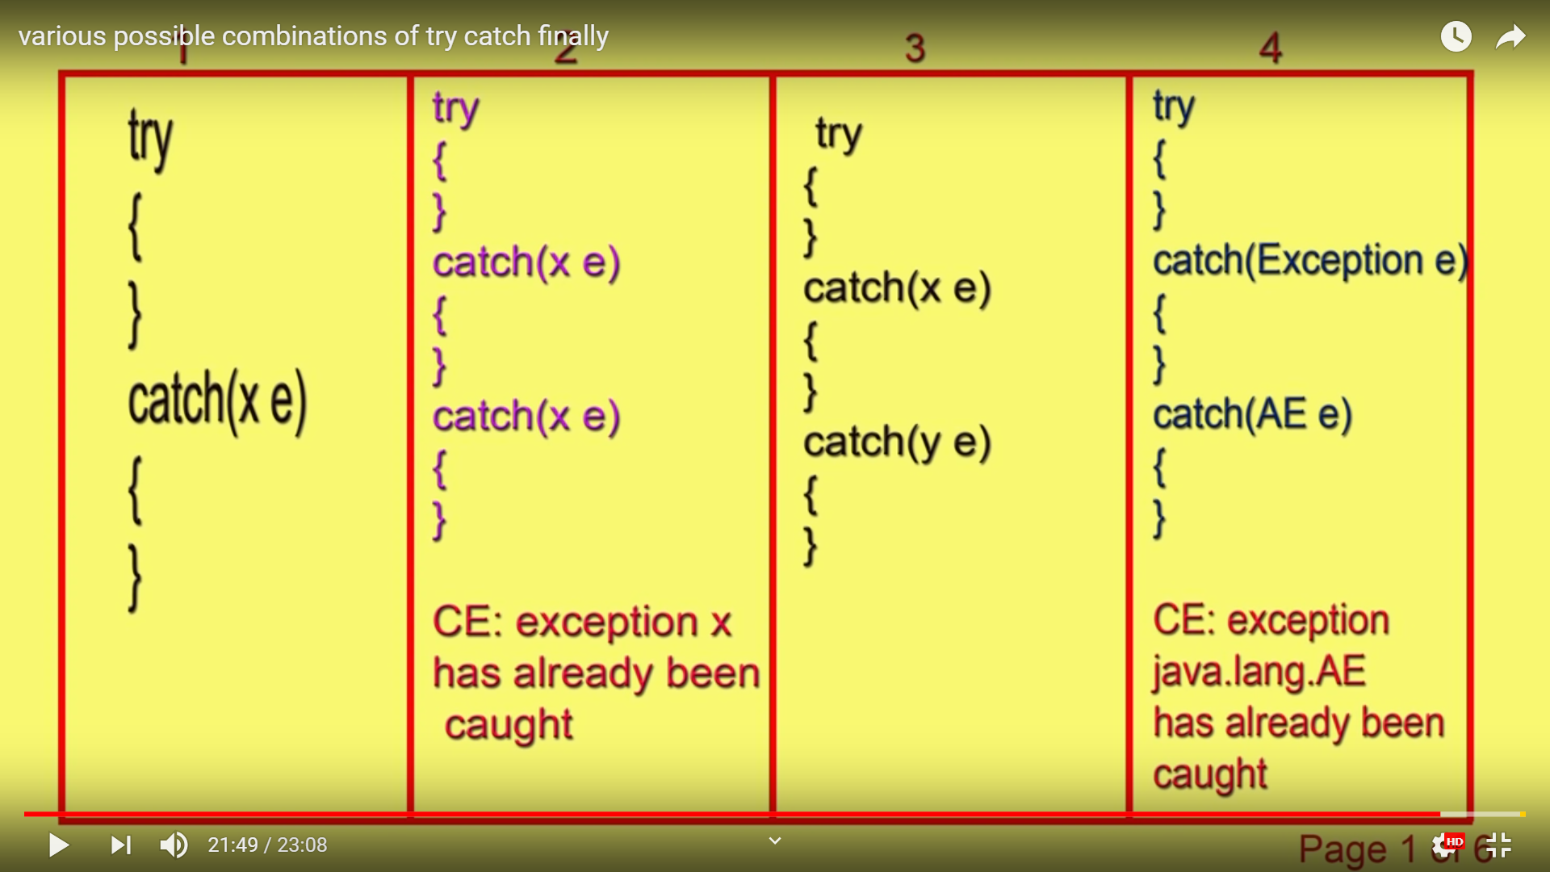

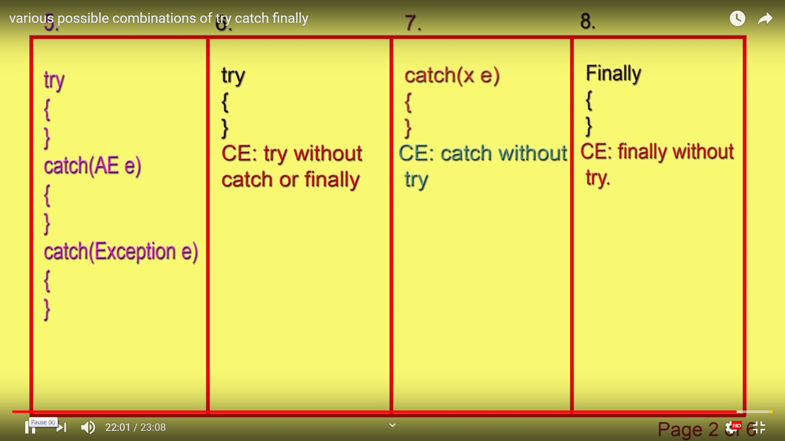

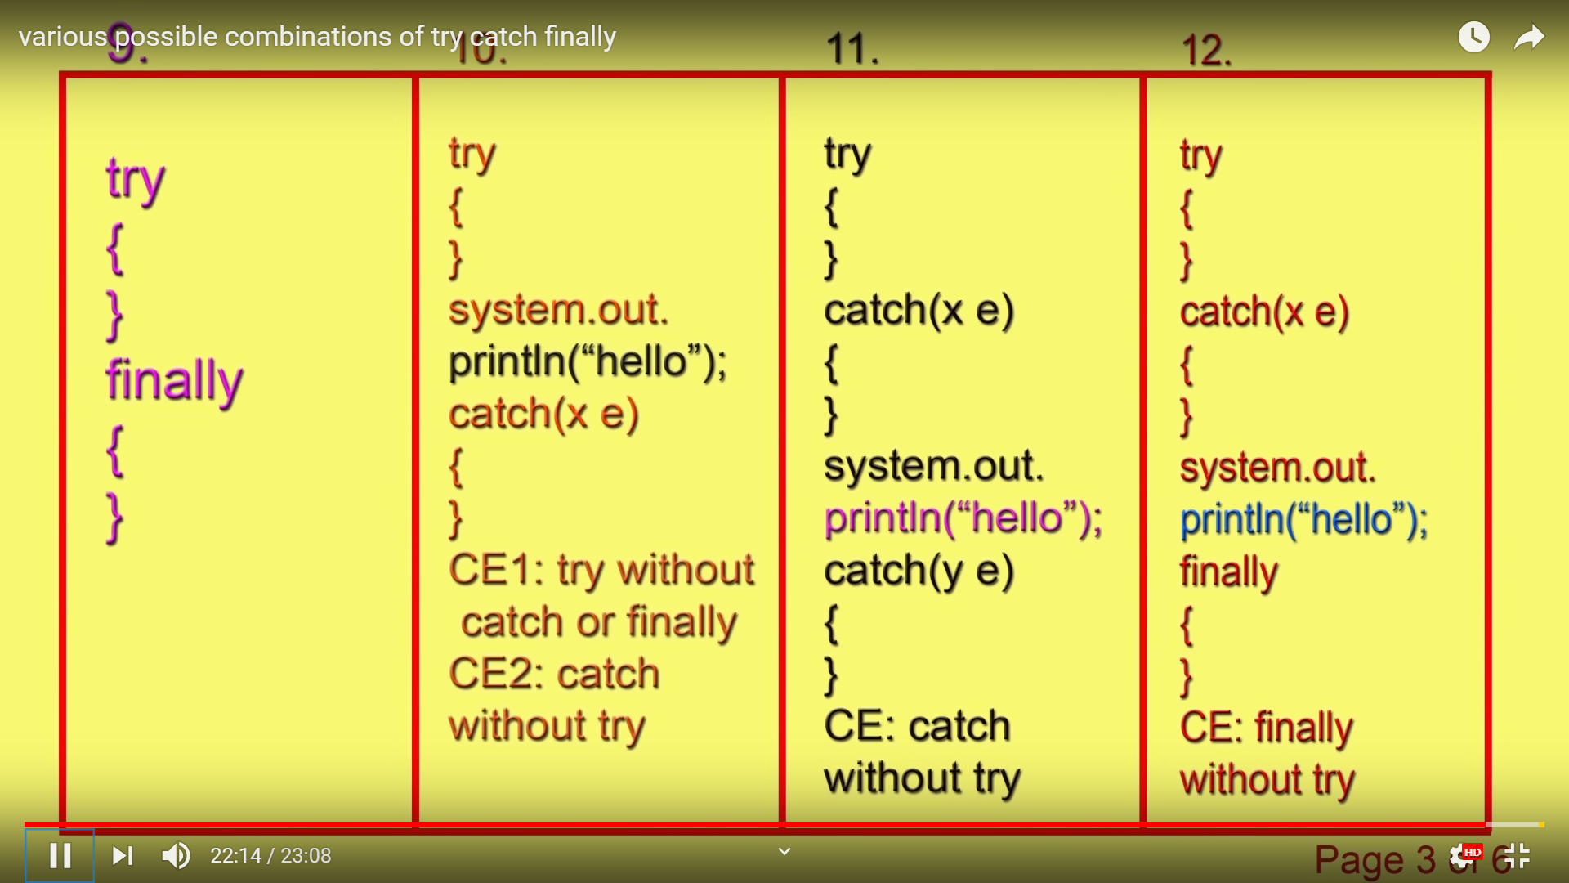

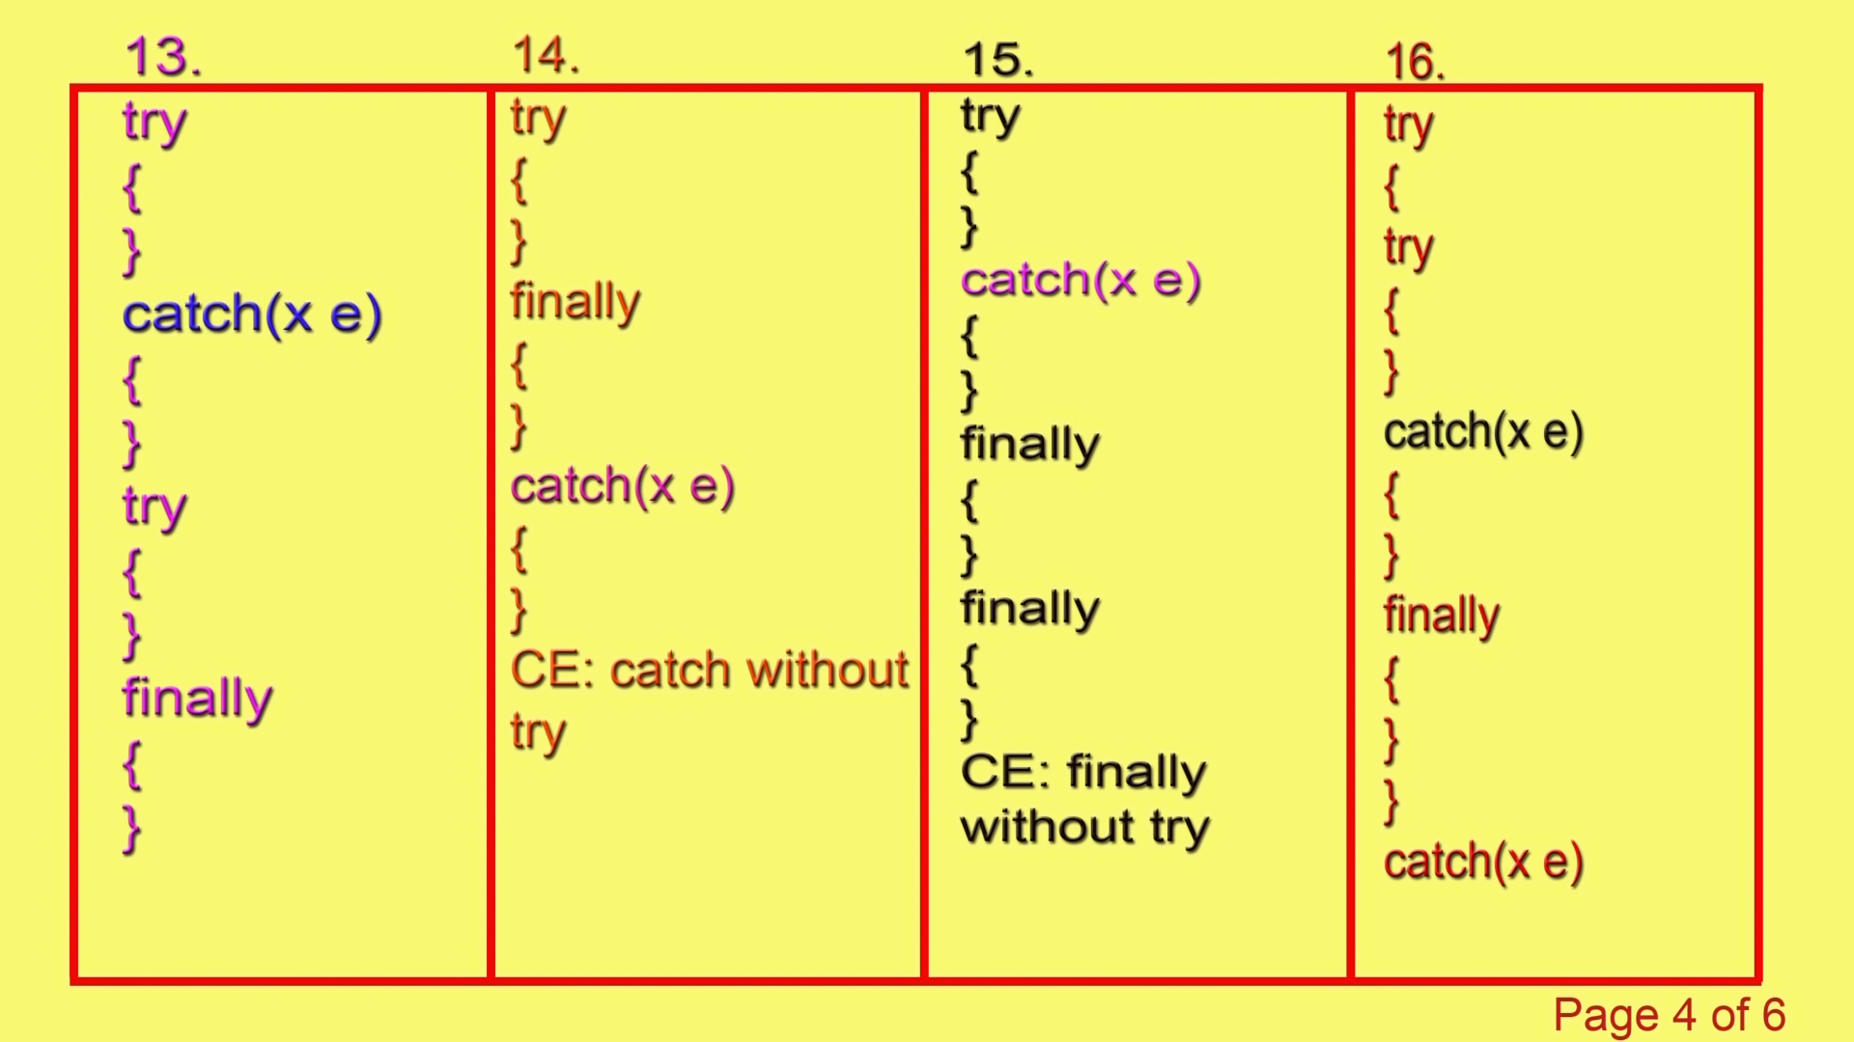

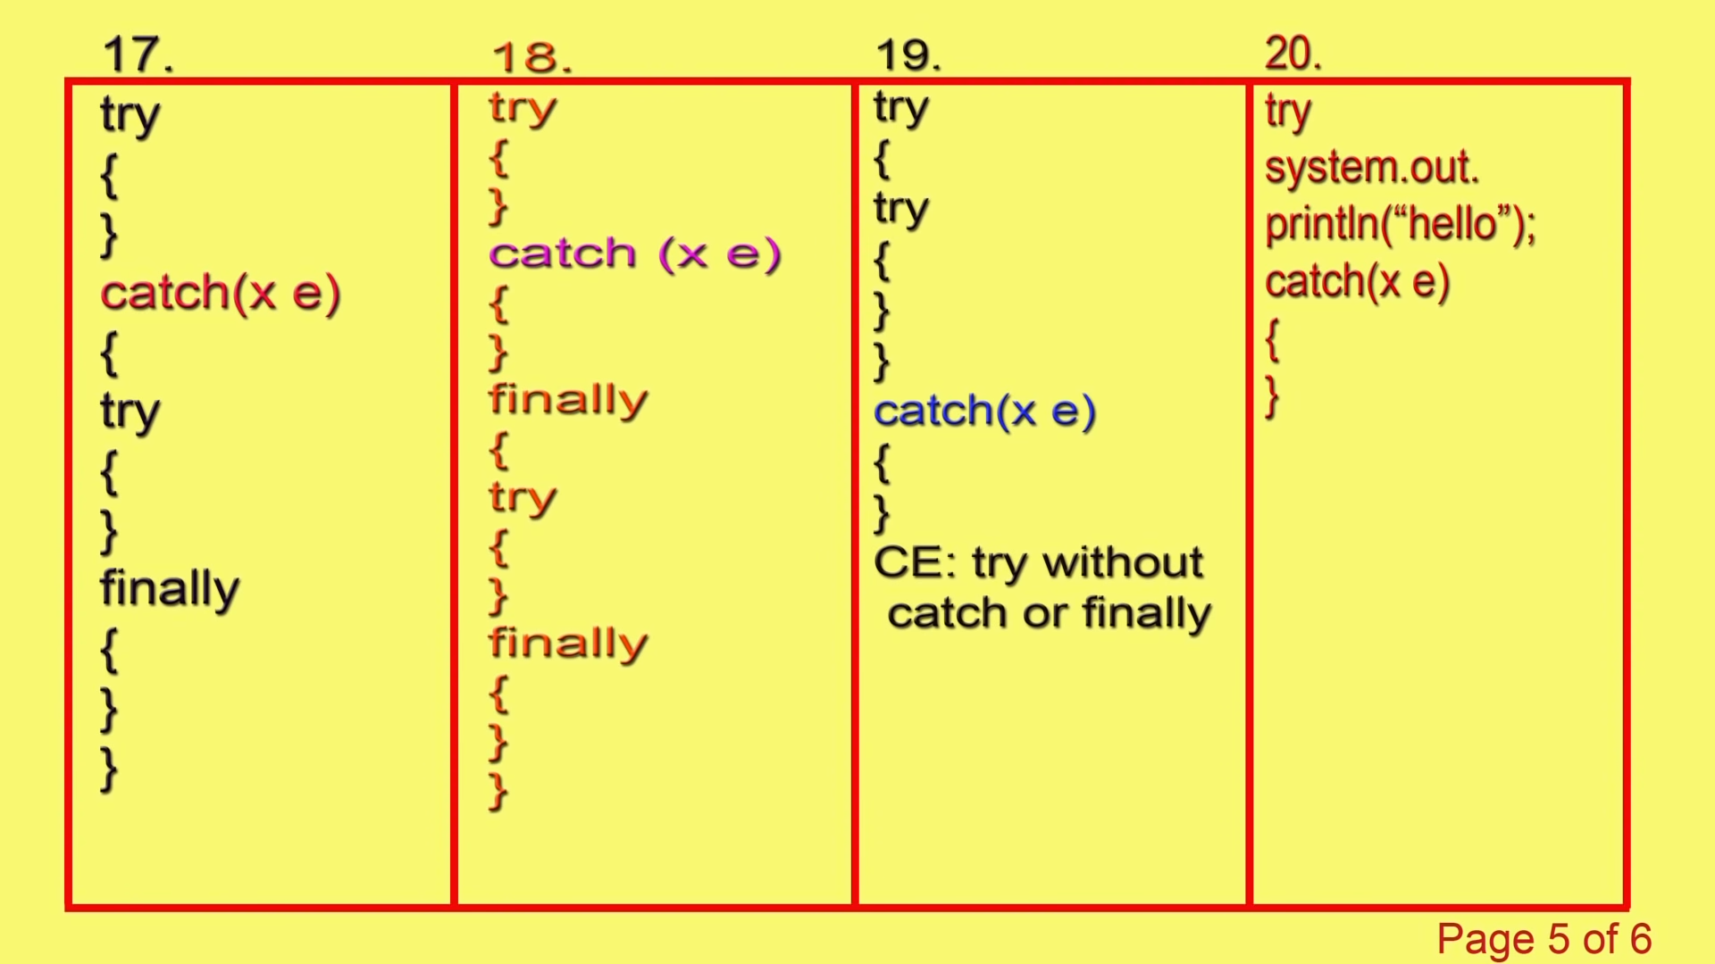

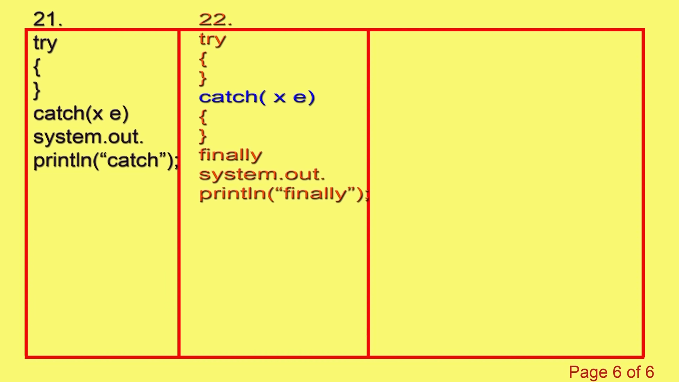

Final : Final is a modifier applicable for classes, methods and variables. If a class declared as final then we can’t extend that class. i.e we can’t create child class for that class.

2. if a method is final then we can’t overrise that method in child class.

3. if a variable is final then it will become constant and we can’t perform re-assignment for that variable.

Finally : Finally is a block always associated with try catch to maintain cleanup code.

Try {

// Risky codes.

}

Catch

{

// Handling Code

}

Finally

{

// Cleaning code.

}

Finalize() : finalize() is a method which is always invoked by garbage collector just before destroying an object to perform cleanup activities.

**** finally meant for clean up activities related to try block where as finalize() meant for clean up activities to object.

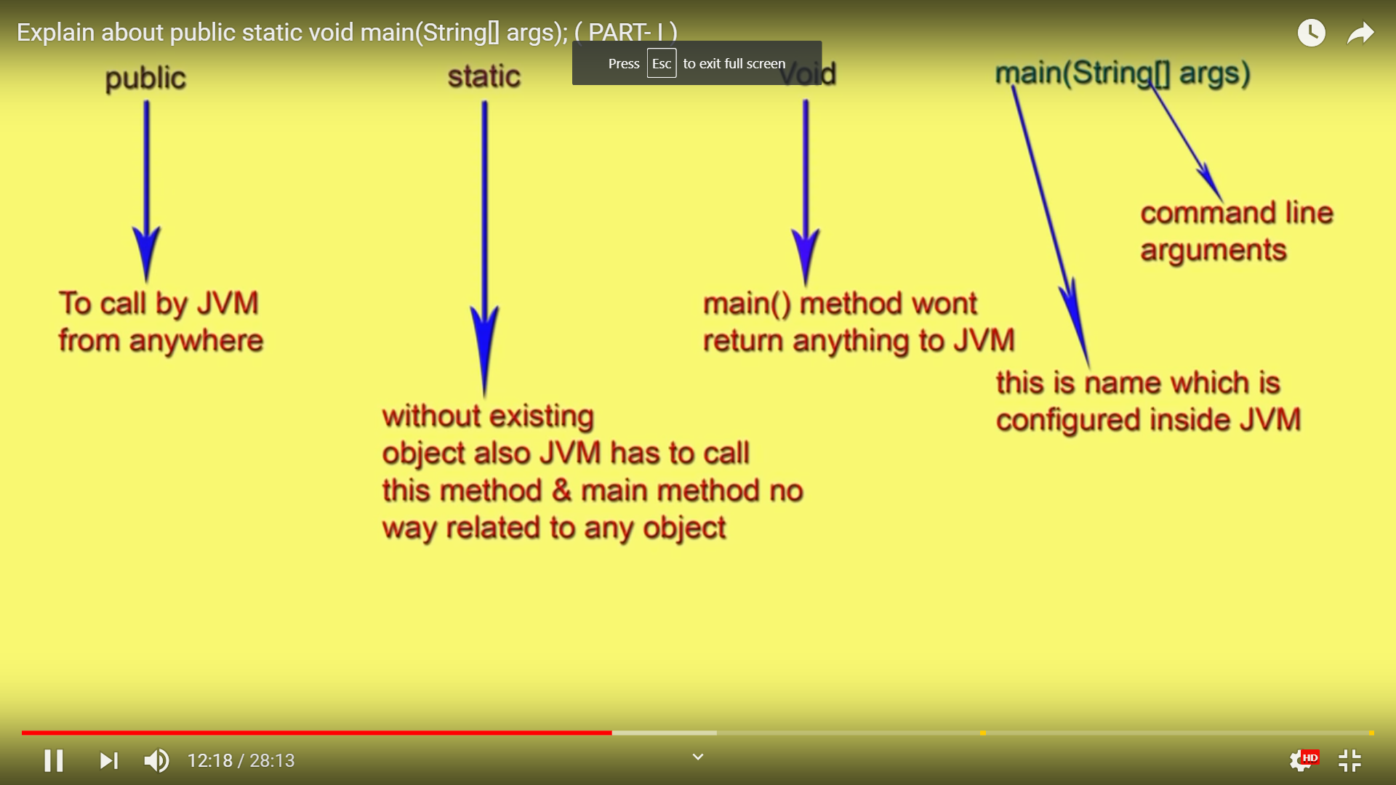

Programmer :

JVM :

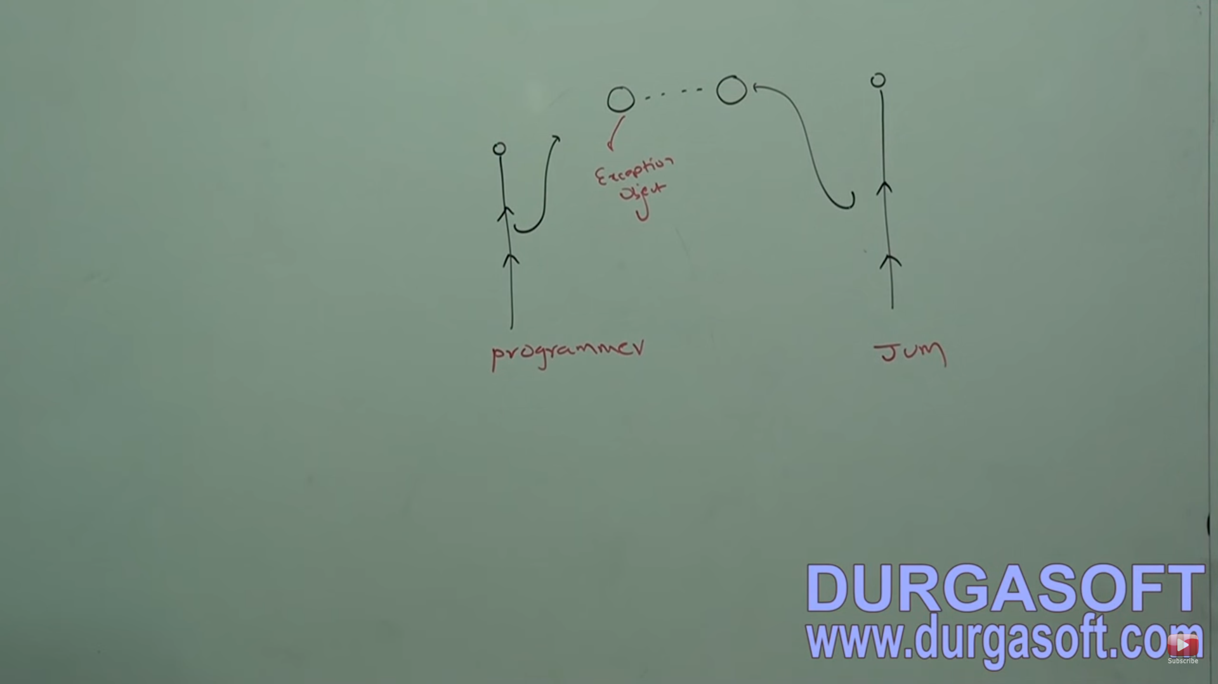

############### 20th feb 2019 #############################

1. *WebDriver driver = new FirefoxDriver();*
2. Here, *WebDriver* is an interface, *driver* is a reference variable, *FirefoxDriver()* is a [Constructor](https://www.softwaretestingmaterial.com/java-tutorial/#constructor), *new*is a keyword, and *new FirefoxDriver()*is an Object.
3. Selenium developers don’t know how all these browsers work. So Selenium developers just declare methods whatever they required and leave the implementation part to the browser developers.

**Local Variable:**

Local variable is a variable which we declare inside a Method. A method will often store its temporary state in local variables.

An abstract class contains both abstract methods and concrete methods(method with body)

**Instance Variable (Non-static):**

Instance variable is a variable which is declared inside a Class but outside a Method. We don’t declare this variable as Static because these variables are non-static variables.

################# 24th Feb 2019 ###############

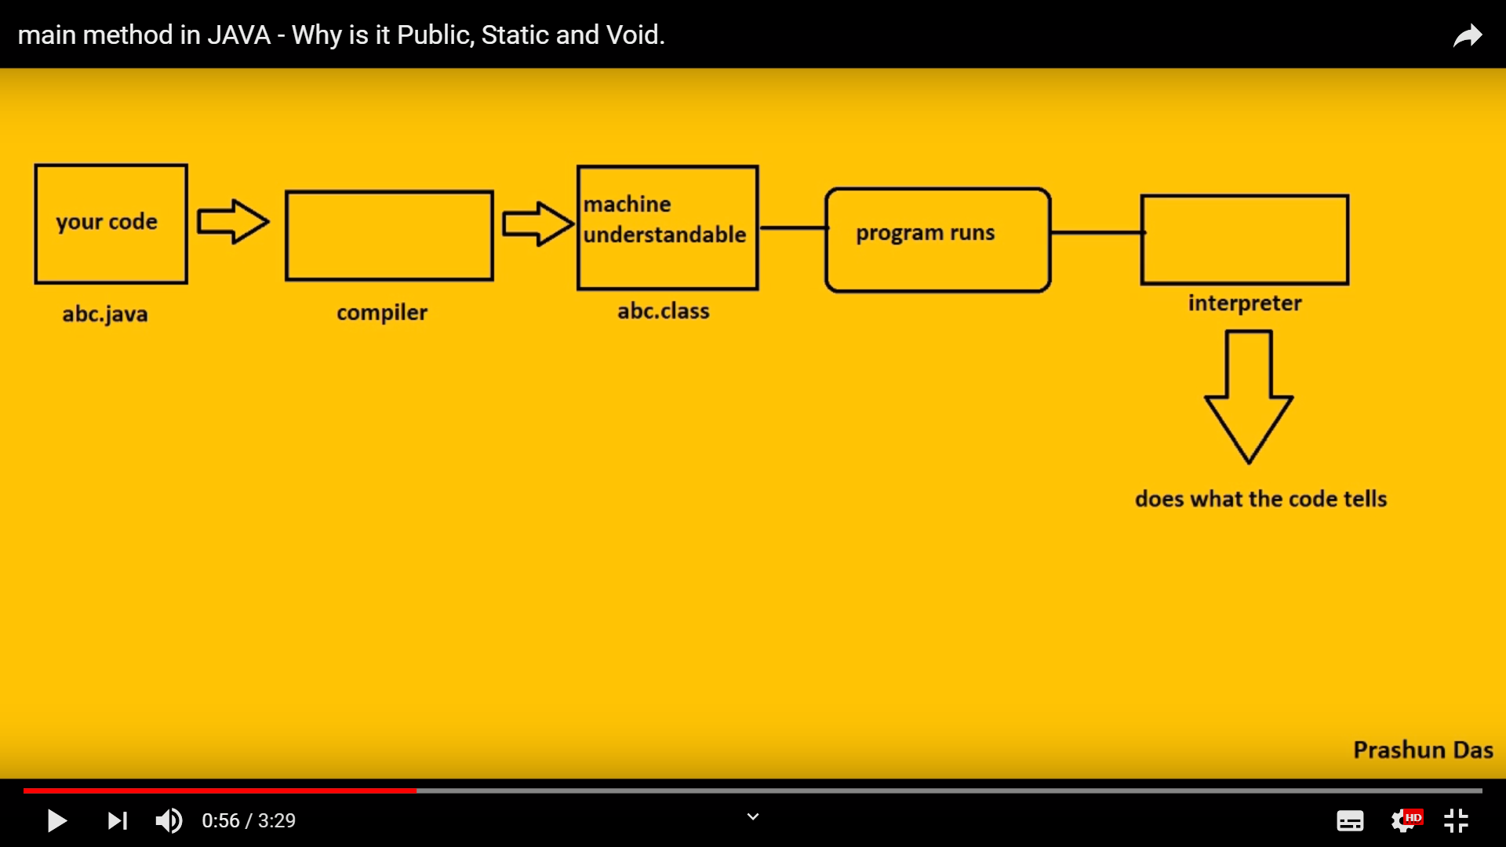

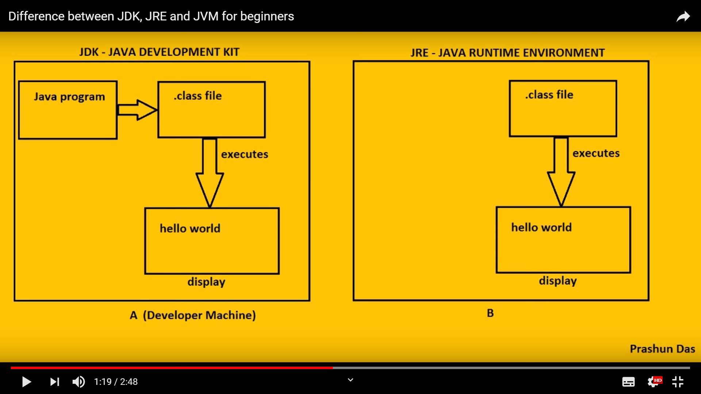

JDK : Development+ Execute + Display result

JRE : Executing + Displaying.

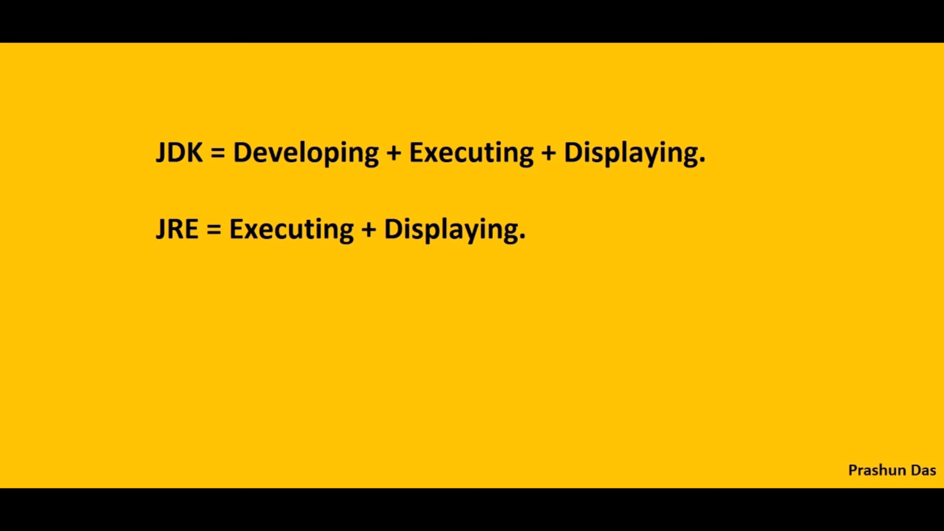

JVM works as interpreter for the code. It reads the .class file line by line.

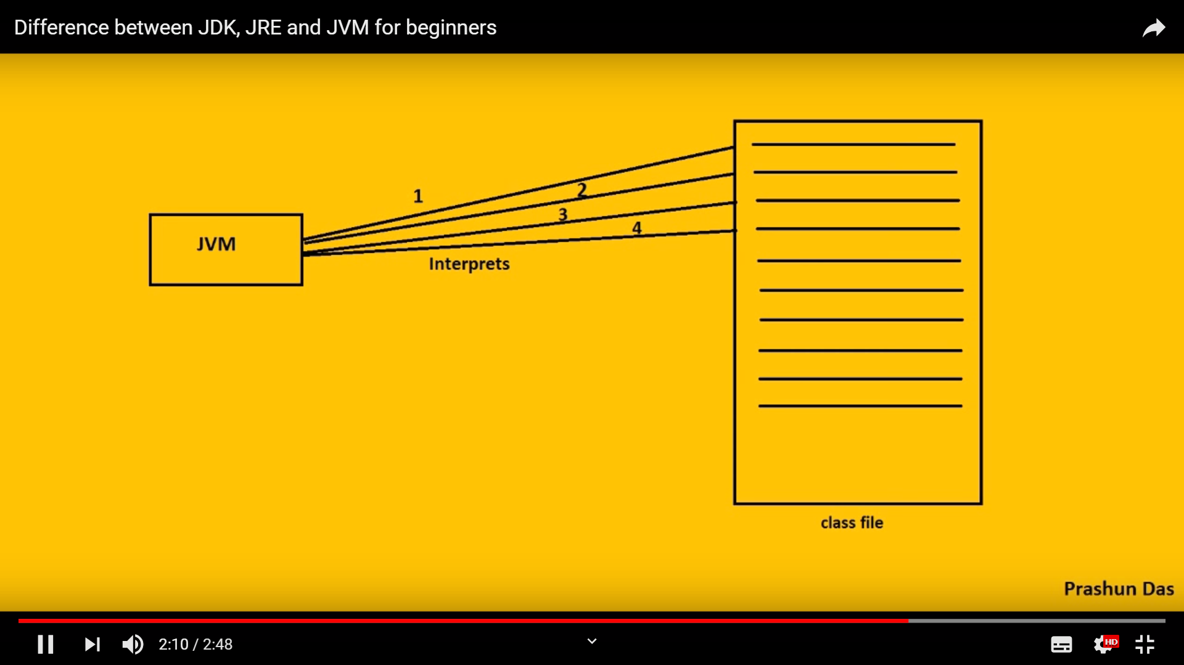

##############Java execution Engine ###############

The main purpose of JIT compiler to improve performance.

Internally, JIT compiler maintains a separate count for every method.

Whenever JVM comes accross any method call, first that method will be interprited normally by the interpriter and GIT compiler increment the corresponding variable .

# This process will be continued for every method.

# Once if any method count reaches threshold value then JIT compiler identify that , the method is repeatadily . That method is called (HOT SPOT)

## Immediately JIT(Just in Time) compiler and generate the corresponding native code. Next time whenever JVM come across that method call then JVM used native code directly and execute it instead of interpreting once again so that performance of the system will be improve.

## the thread count varied from JVM to JVM.

### Some advance JVM,, recompile the native code when counts reaches threshold value second time. so that more optimised code is generated.

### Internally, profiler ( part of JIT compiler) is responsible to identify hot spots.

Note : JVM interprets total programs atlest once.

2. JIT compilation is applicable only for repeatidaly required methods not for every mthods.

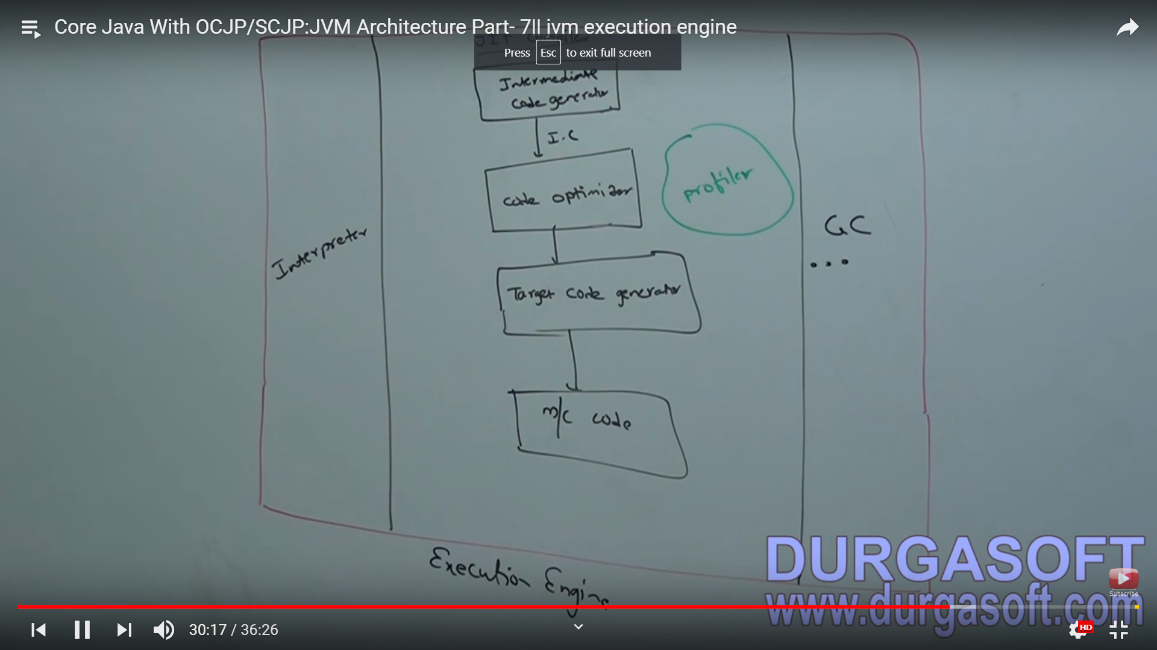

#### Parent reference can be used to hold any child class object.

Example : Parent P = new Child();

Here Parent reference can call the methods which is available under parent class. Child class methods can’t be called using Parenet reference.

**Note** : if we do not know the exact runtime type of object then we should use this approach ( Polymorphism).

Try : To maintain risky code.

Catch : To maintain exception handling code.

Finally Block : To maintain clean up code.

Throw Keyword : To handover our created exception object to JVM manually.

Throws Keyword : To delegate responsibility of exception handling to the called ( Method or JVM)

// Note : Whenever we are trying to print any refernece varaiable, internally toString method is called.

// which is implemented by default to return the sting in following form.

// classname@HashcodeinHexaDecimal form.

#######################26th Feb ################

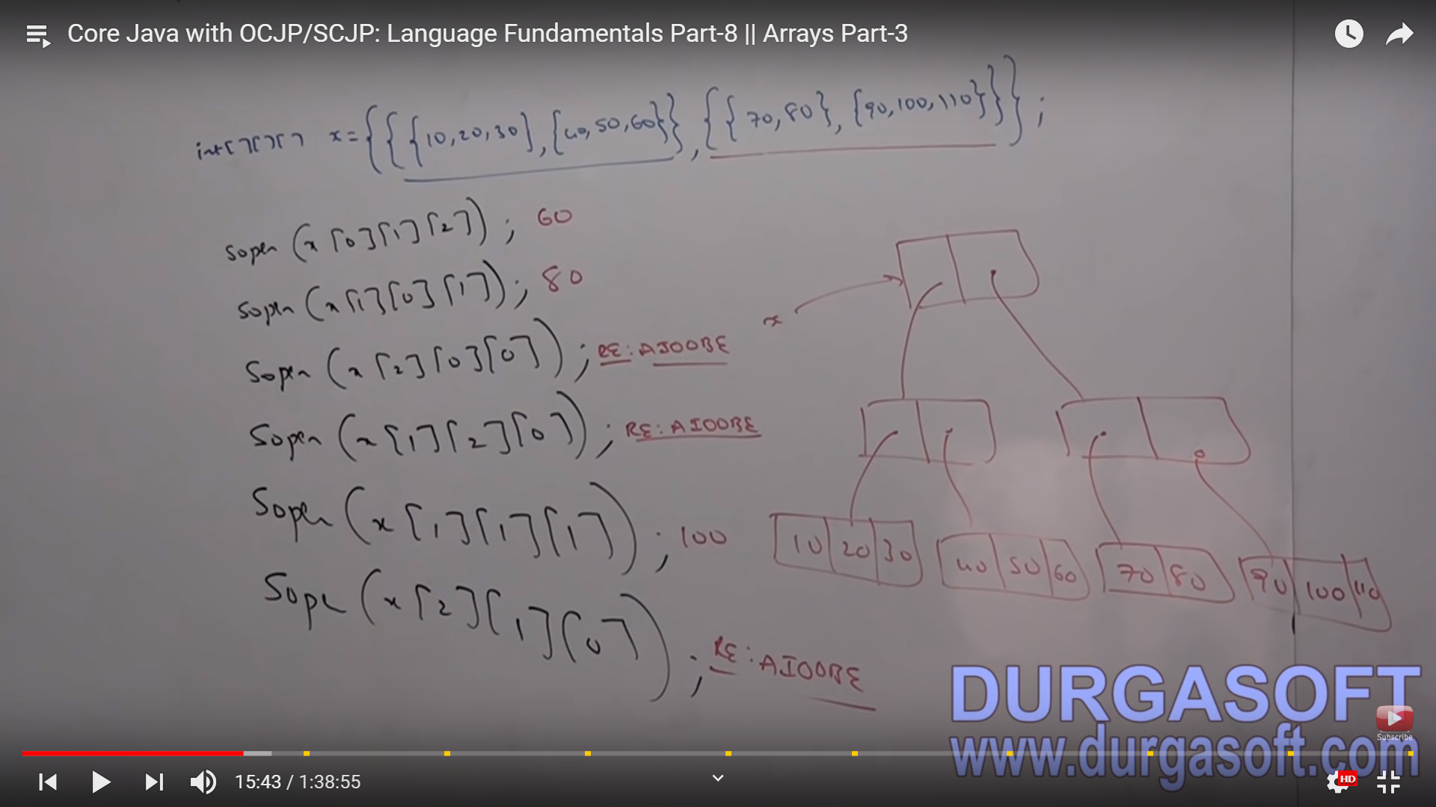

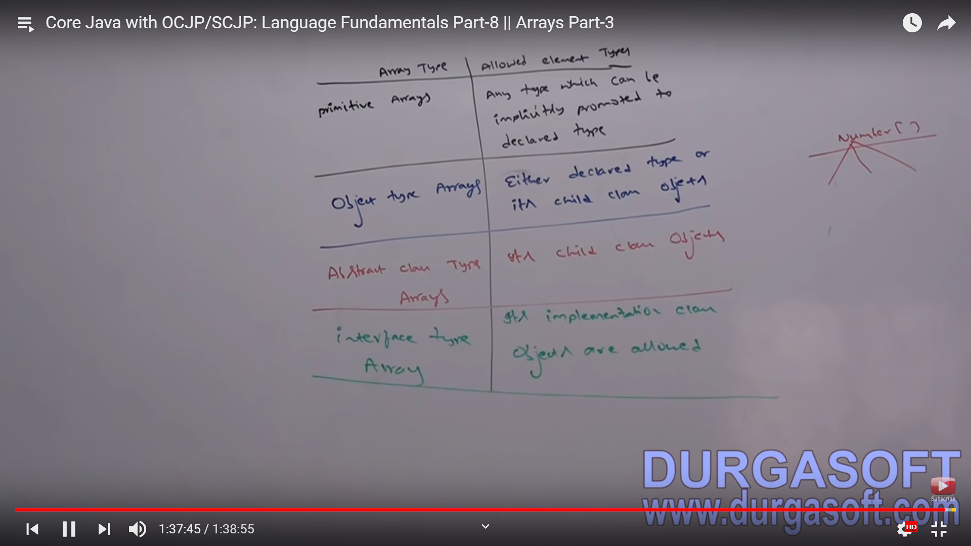

####################27th Feb ##########

Typecasting

Link : https://www.youtube.com/watch?v=HpJTGW9AwX0&t=39s

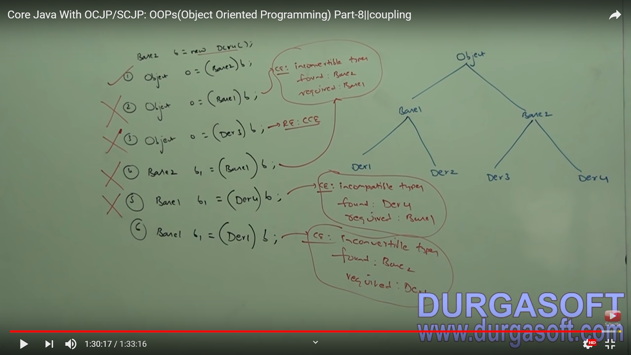

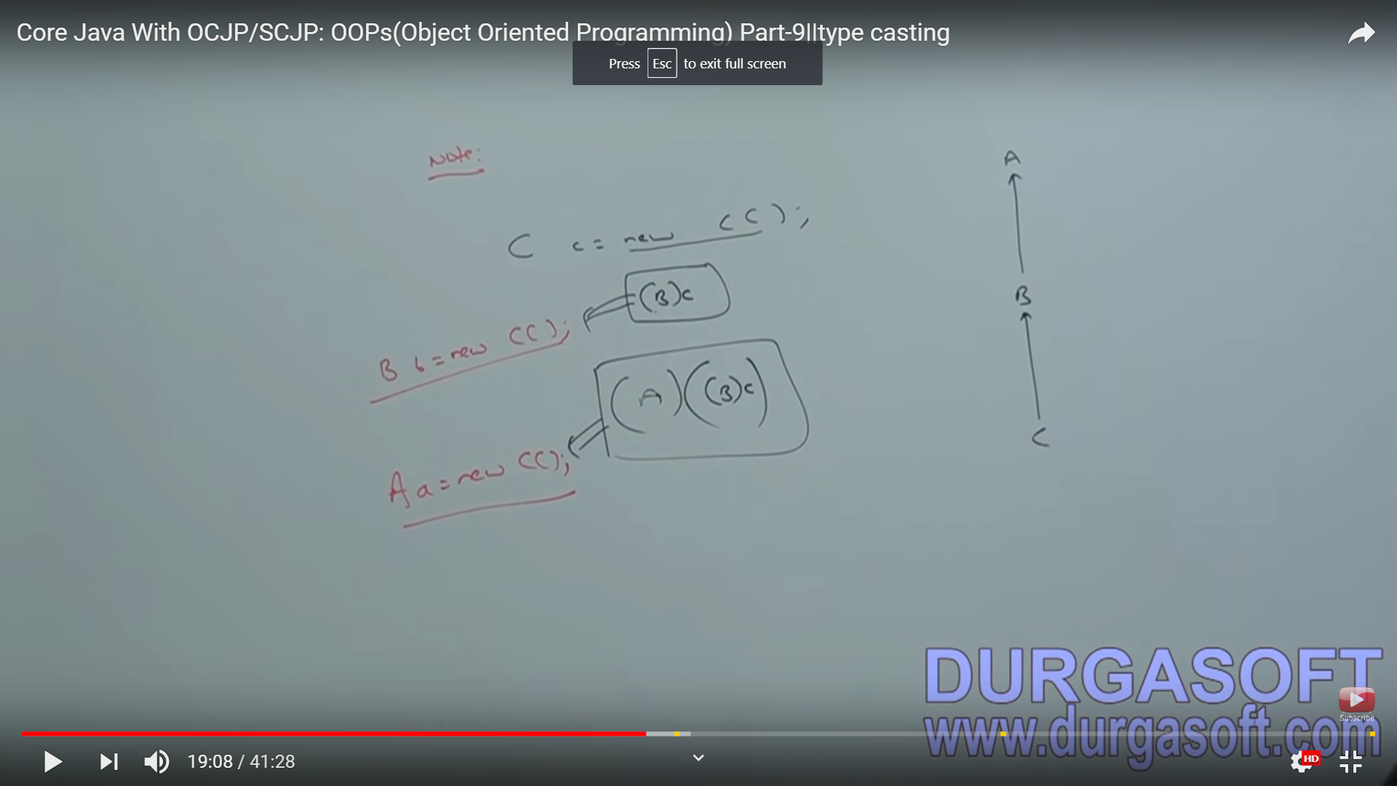

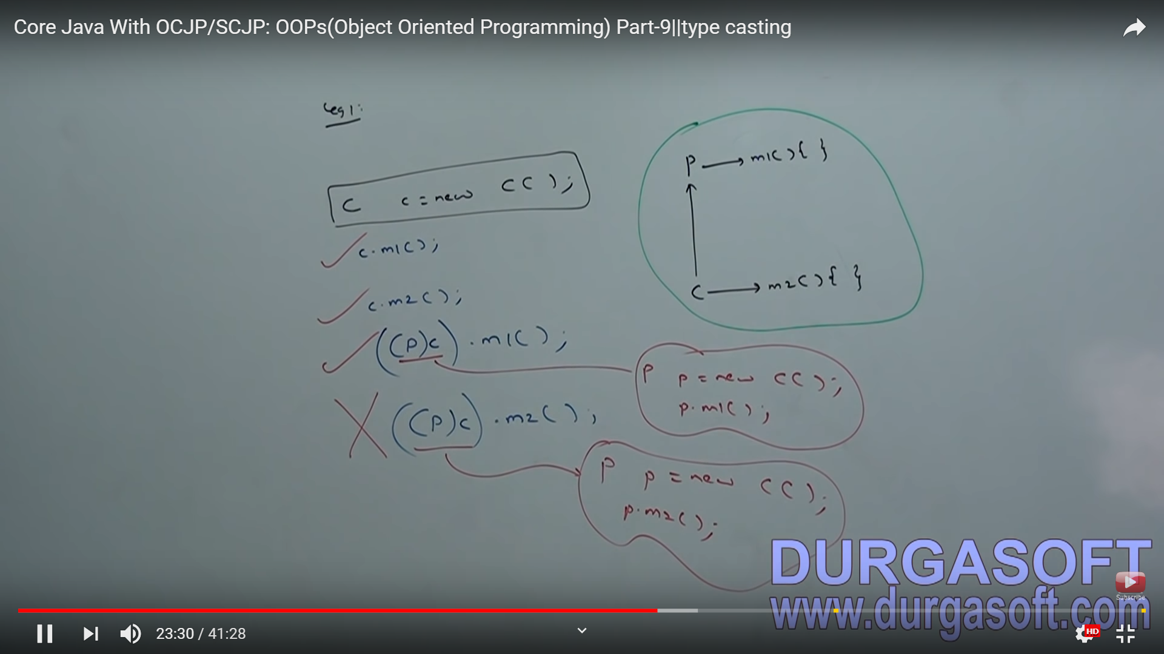

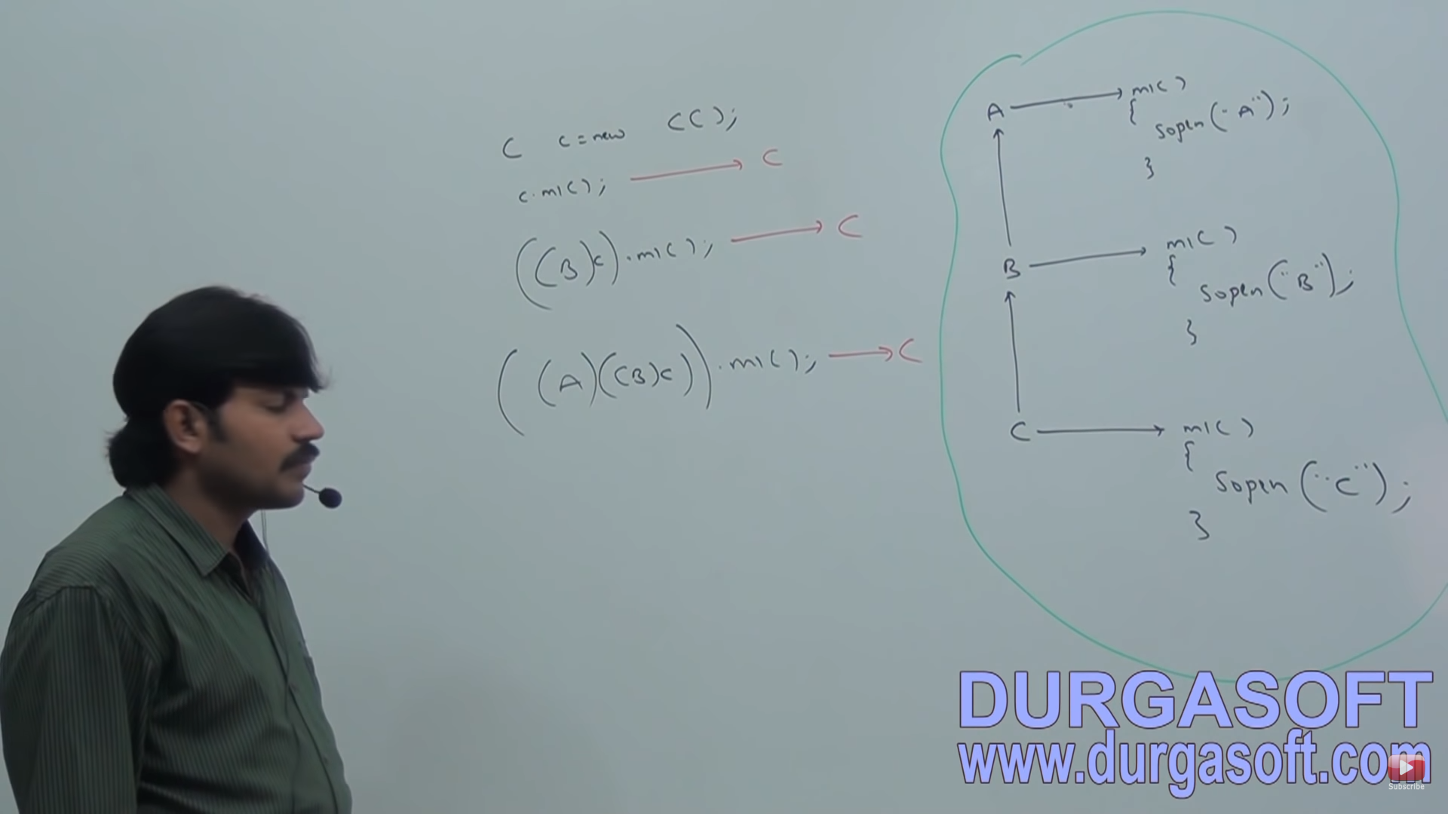

// Variable resolution is always based on reference type but not based run time object.

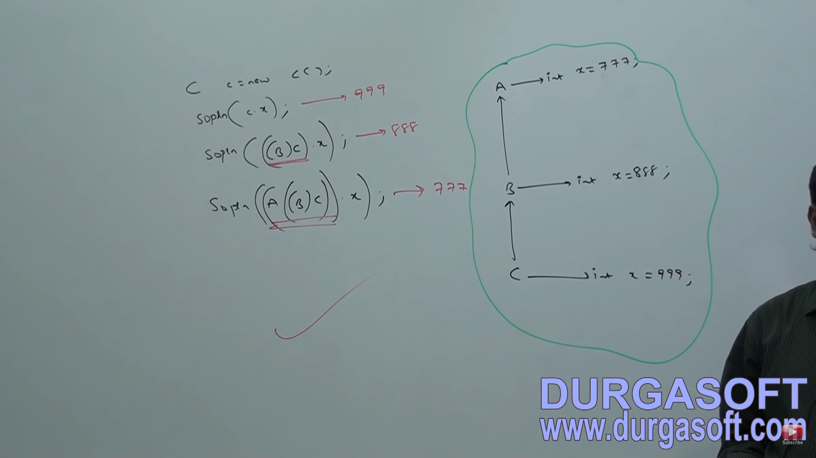

#################### Staic Control Flow ( 28th feb 2017) #############################

Link : https://www.youtube.com/watch?v=B_tYO3Yn61U

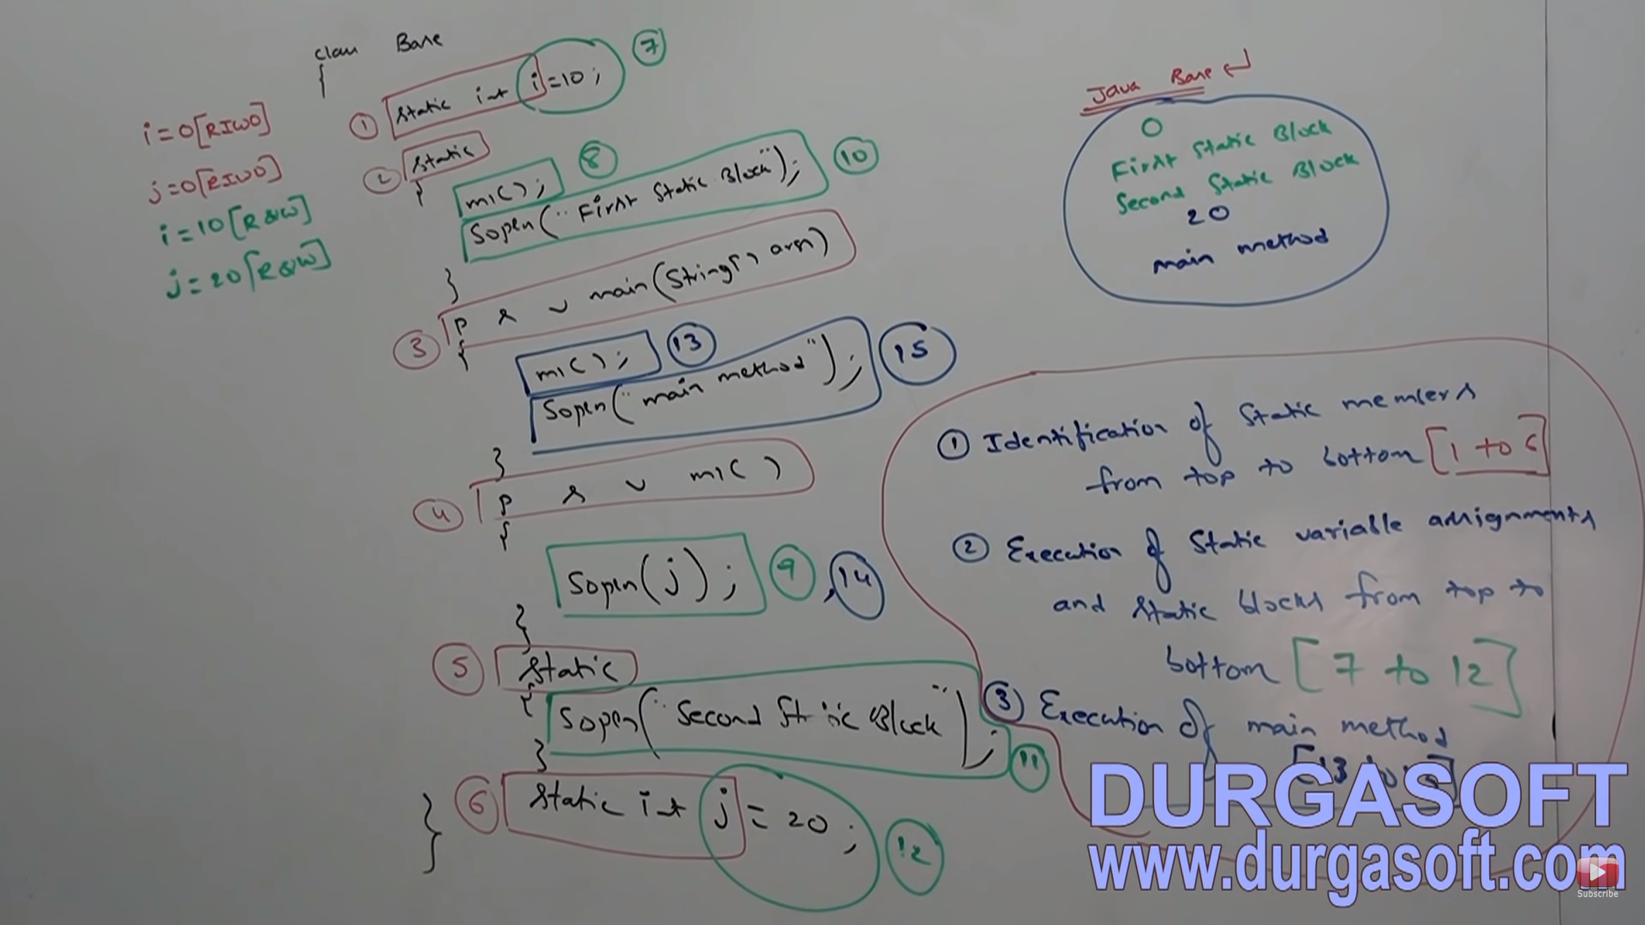

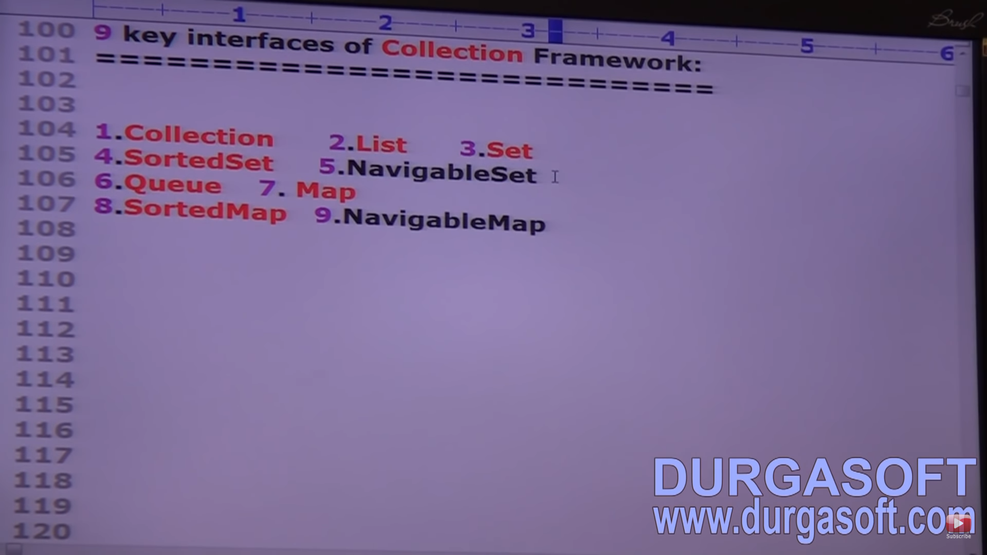

########Linked List ##############

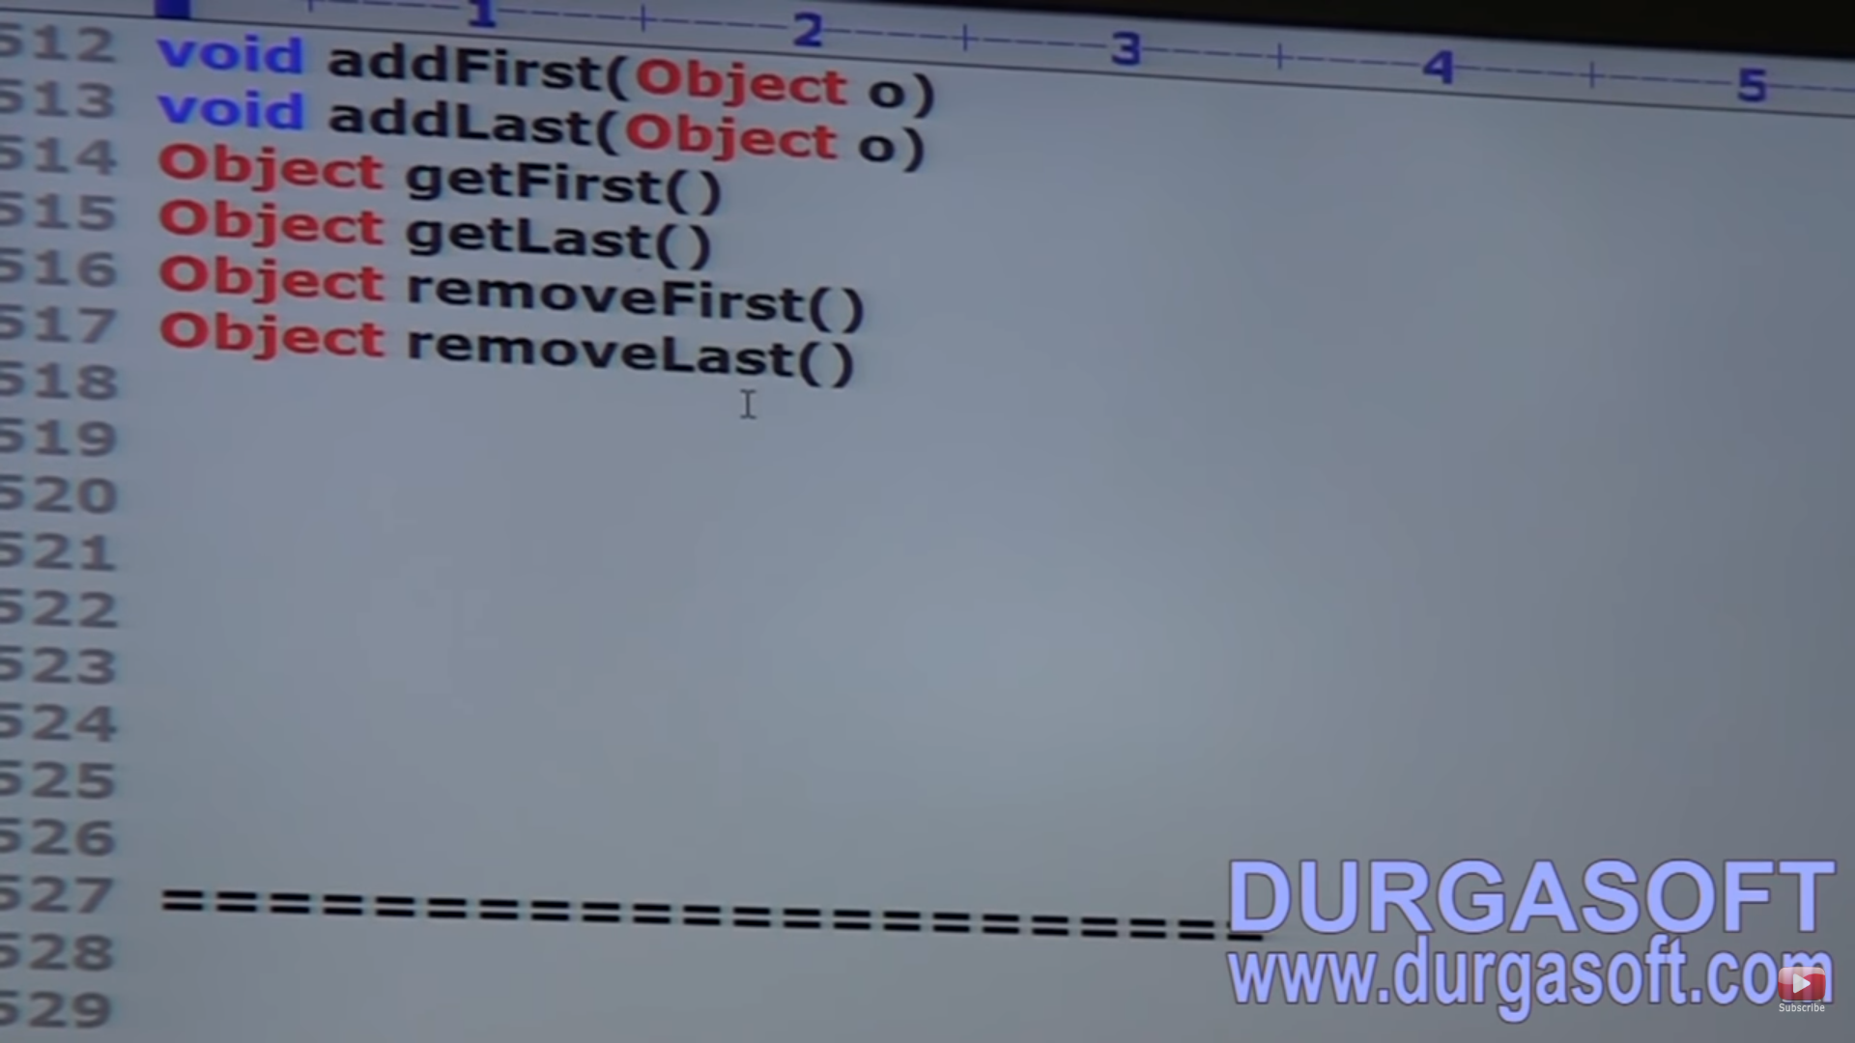

##########################1st march 2019 #######################

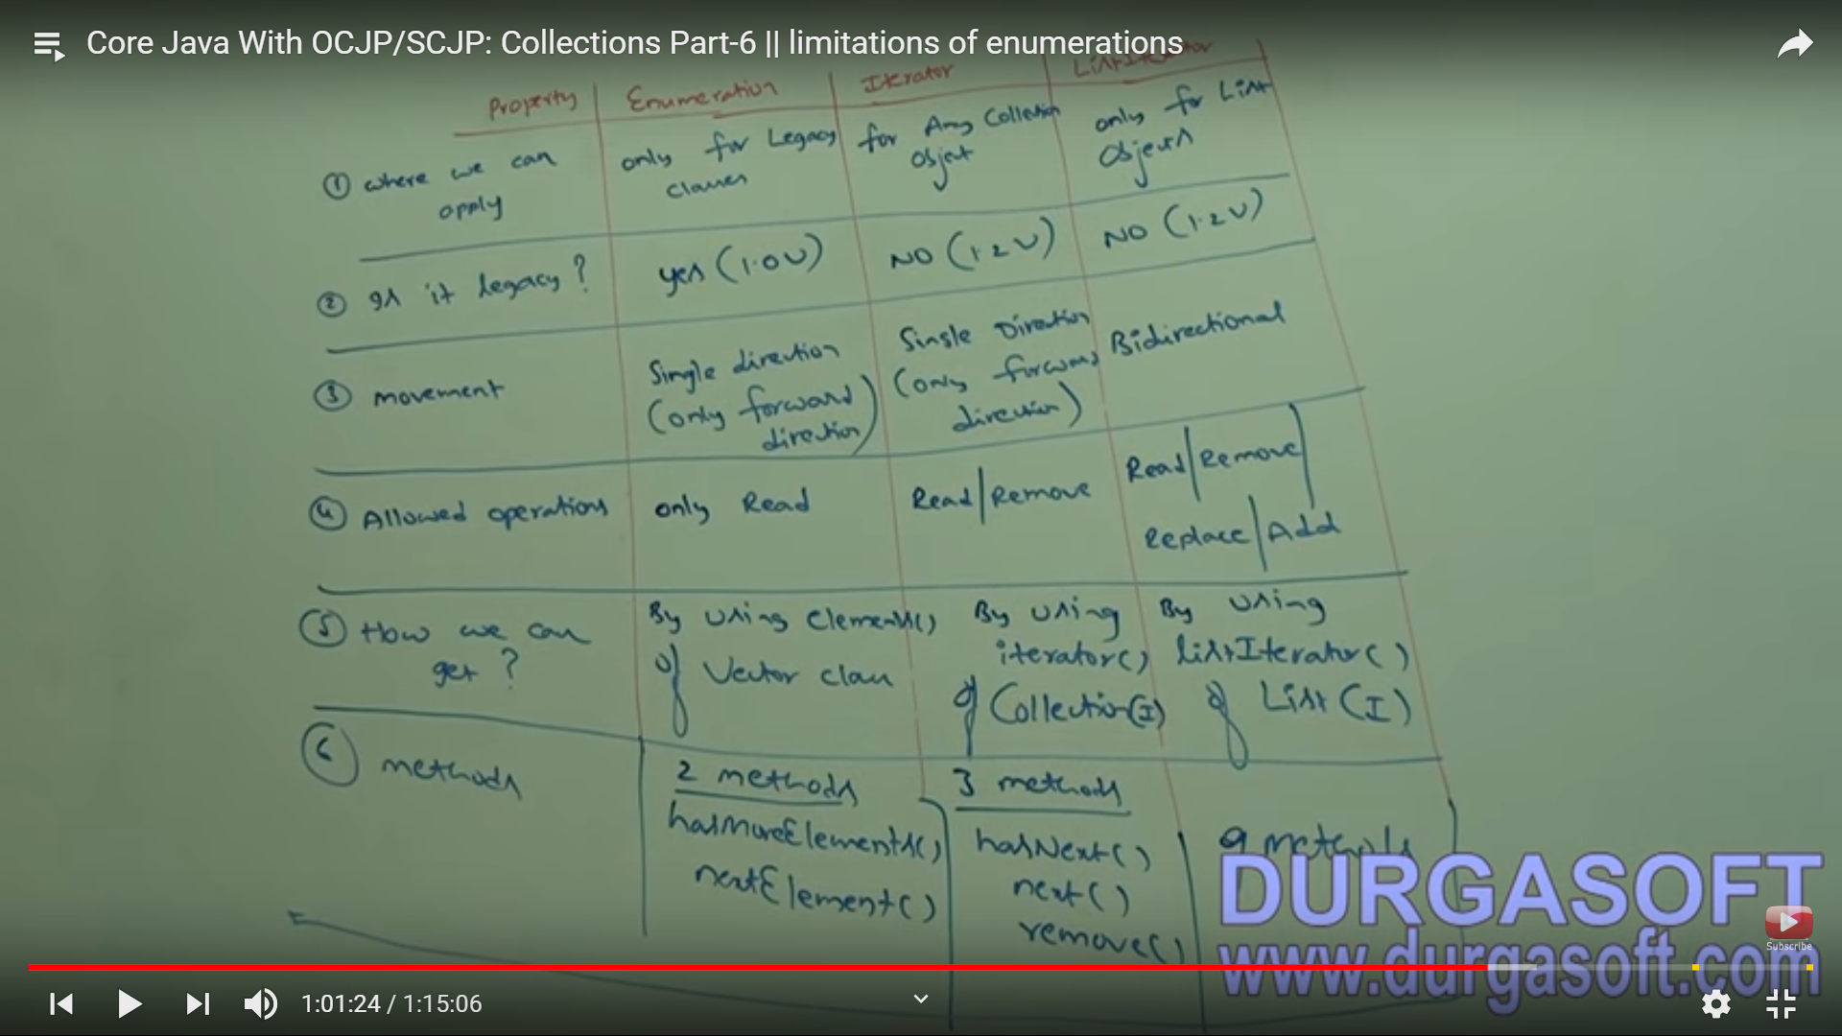

########################Sorted set method ######

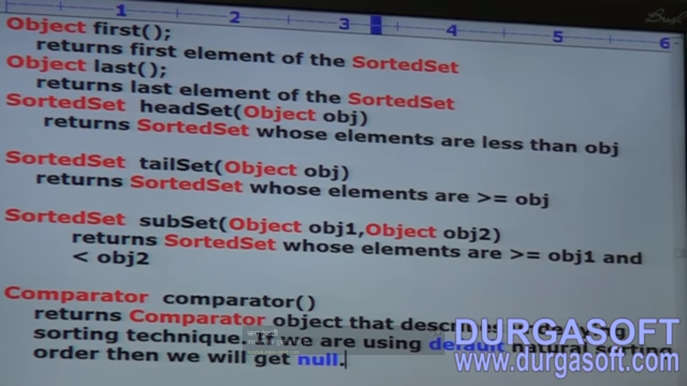

################### Comparator example #########################

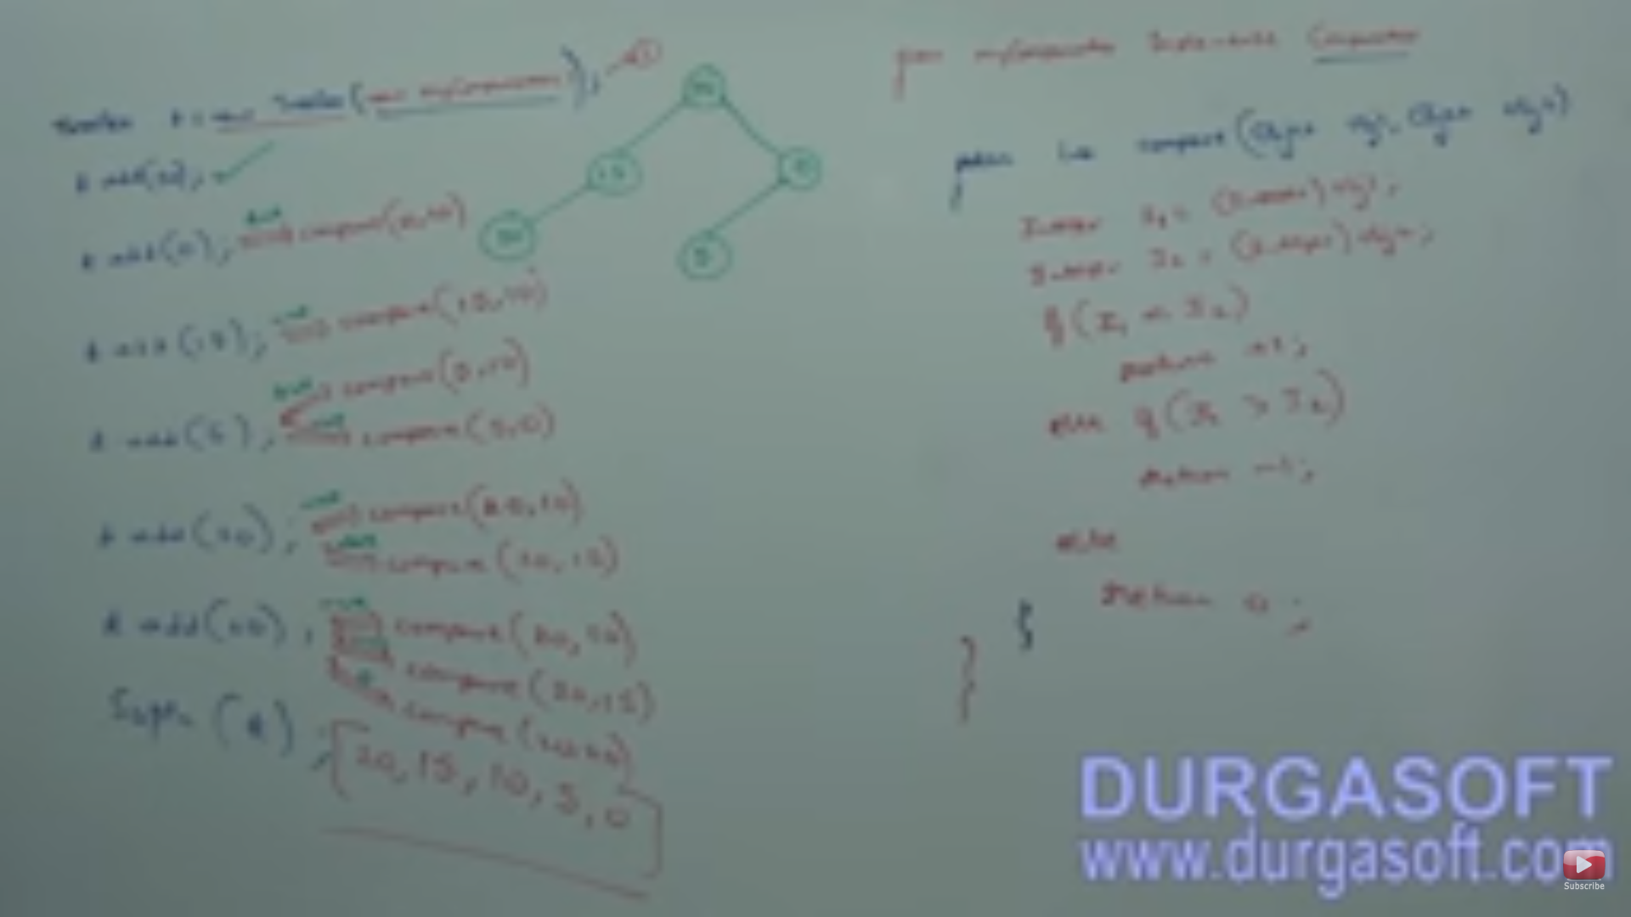

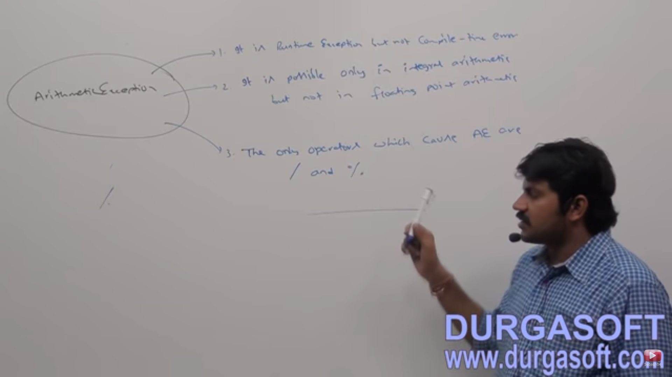

Explicit Type casting example :

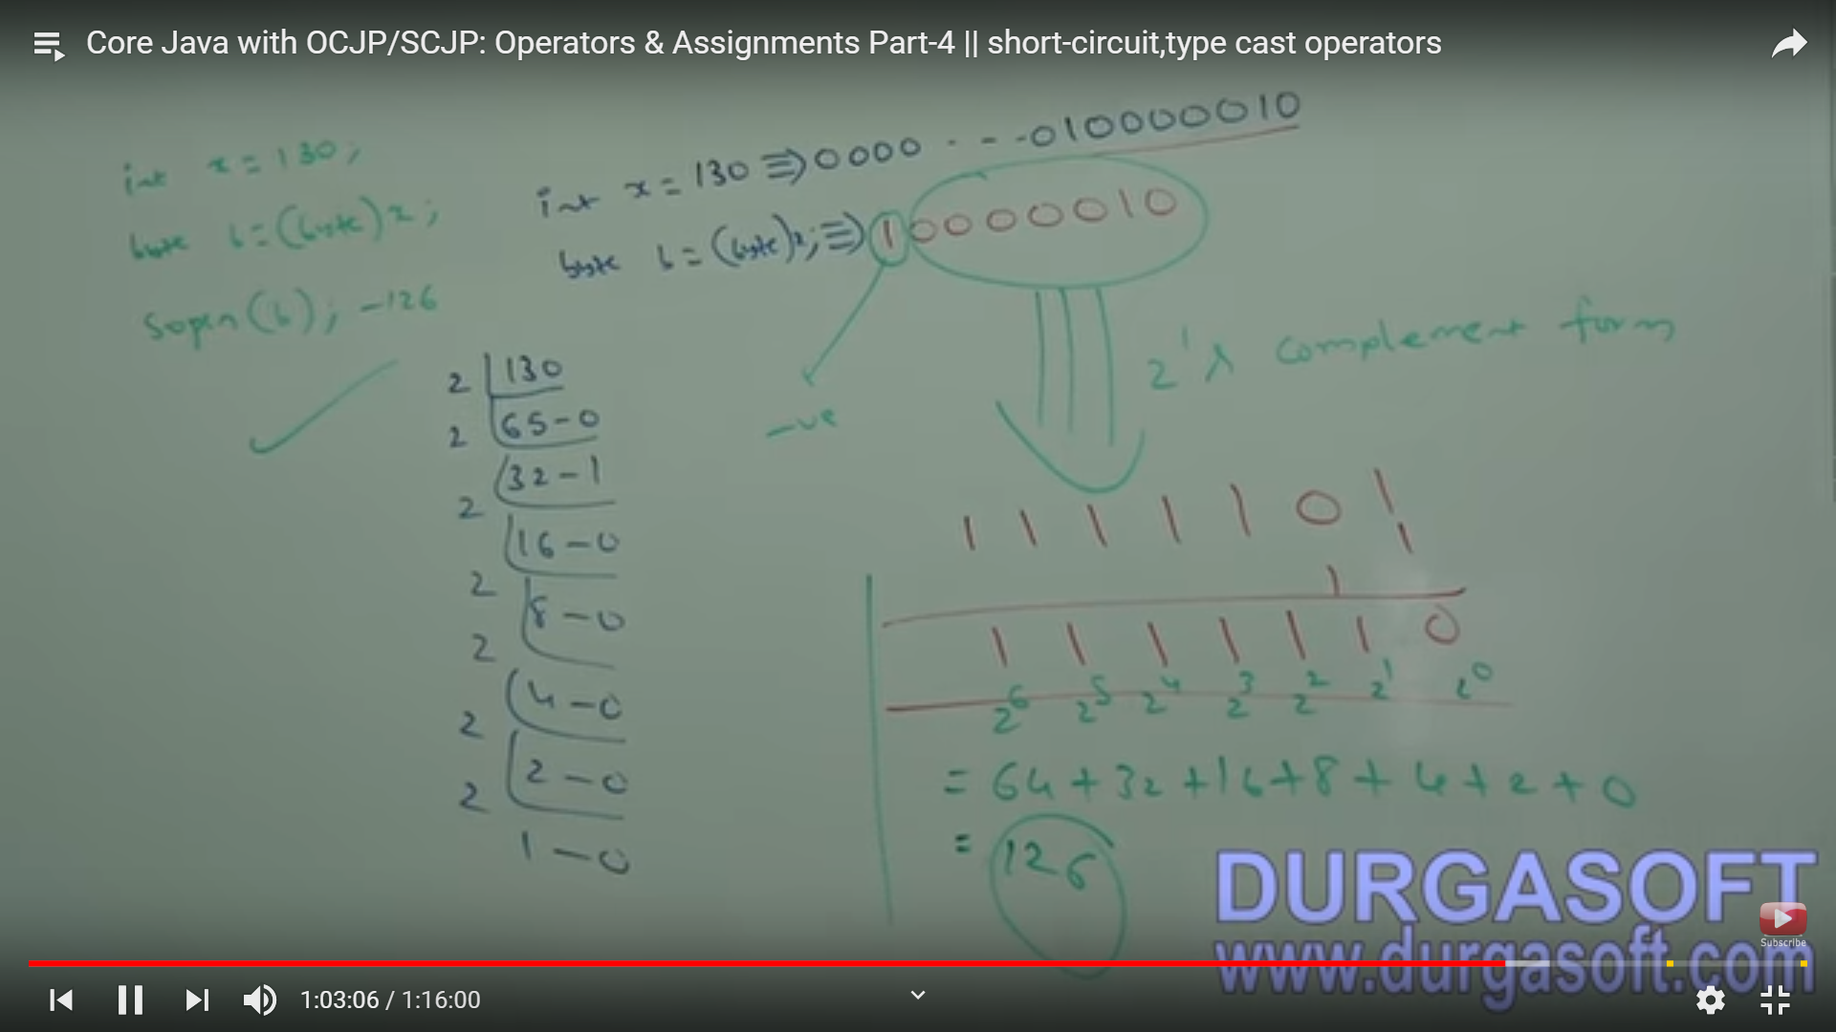

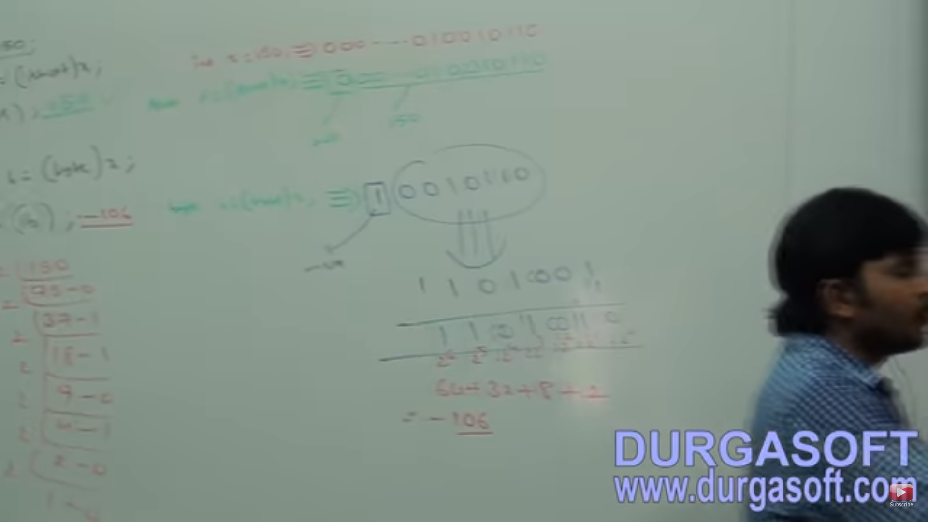

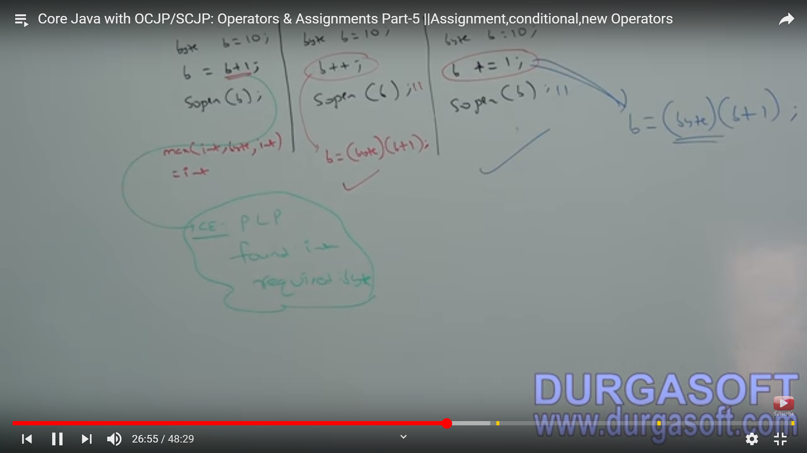

################Java Operator Precedence ############################

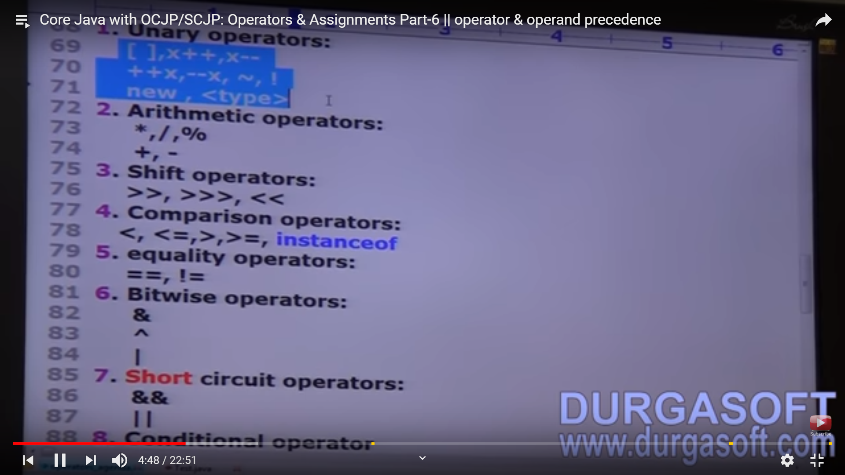

// if same precedence will be available then evaluation will start from left to Right.

String a = ‘’deepak”;

Int b=20, c=30,40=50;

Syso (a+b+c+d)

####################### All methods name defines under Object class ############

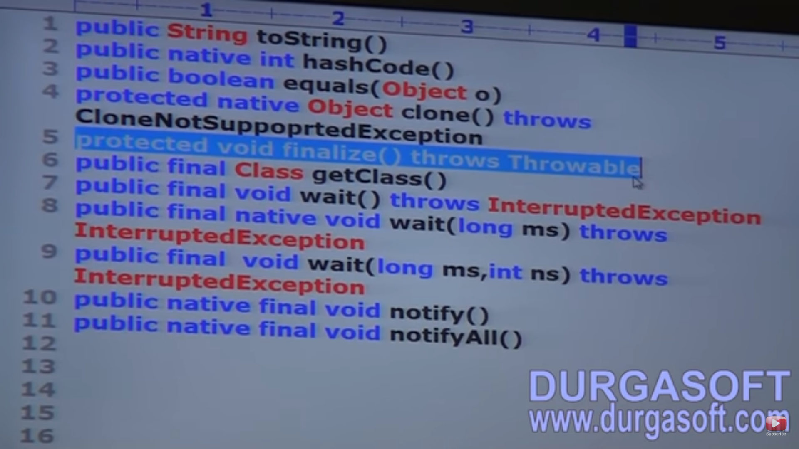

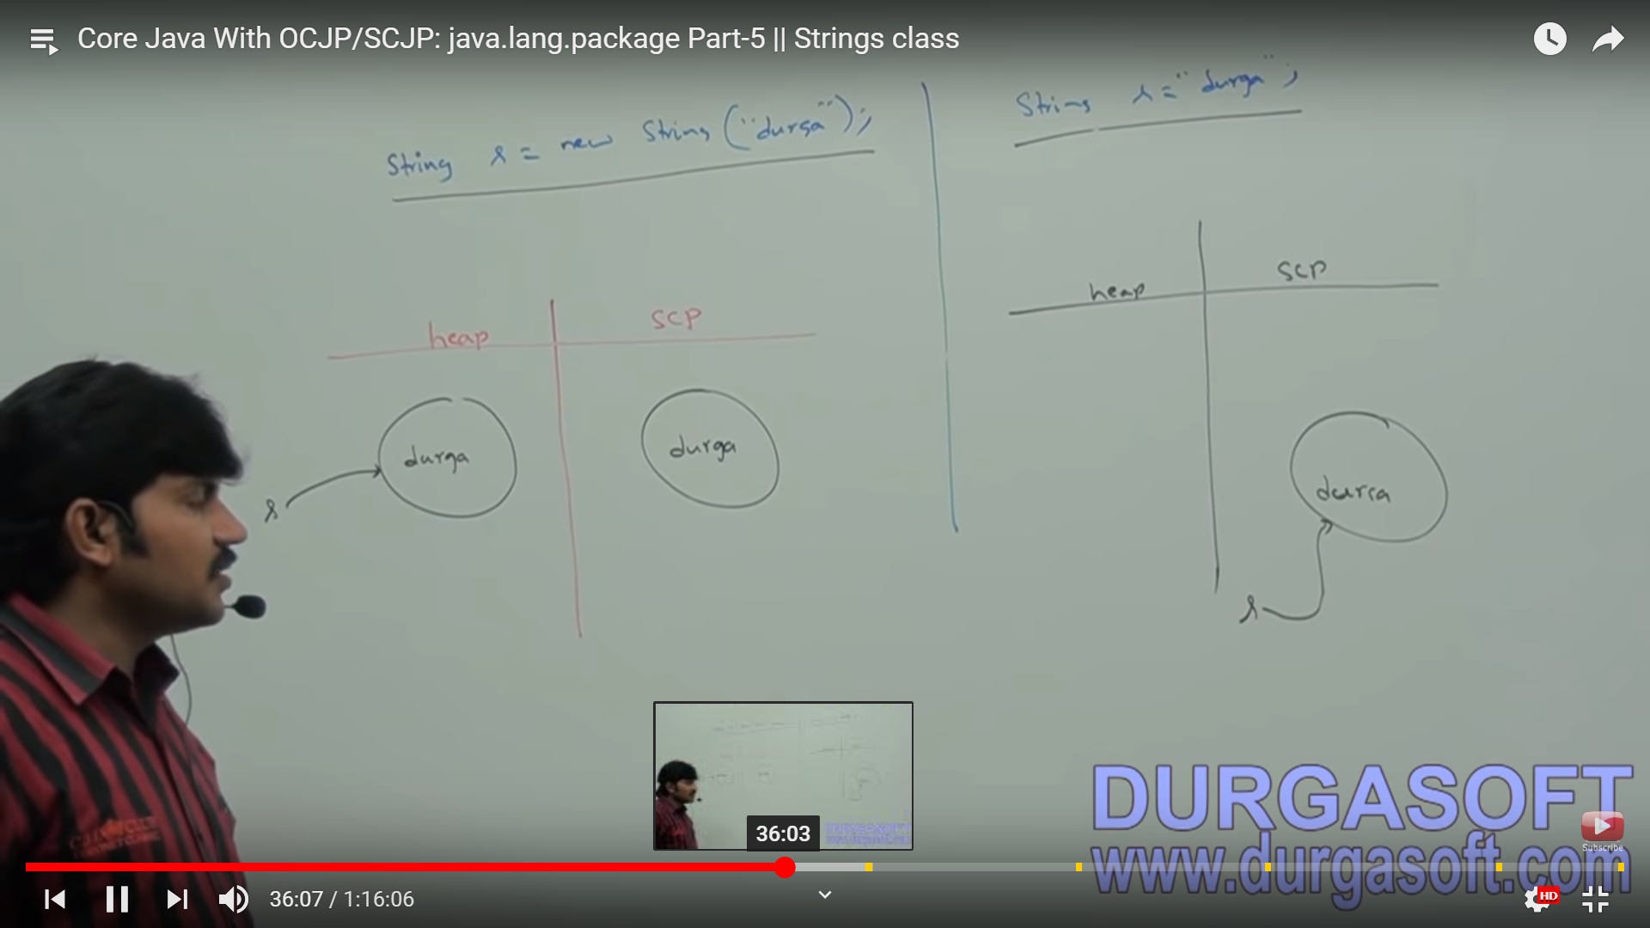

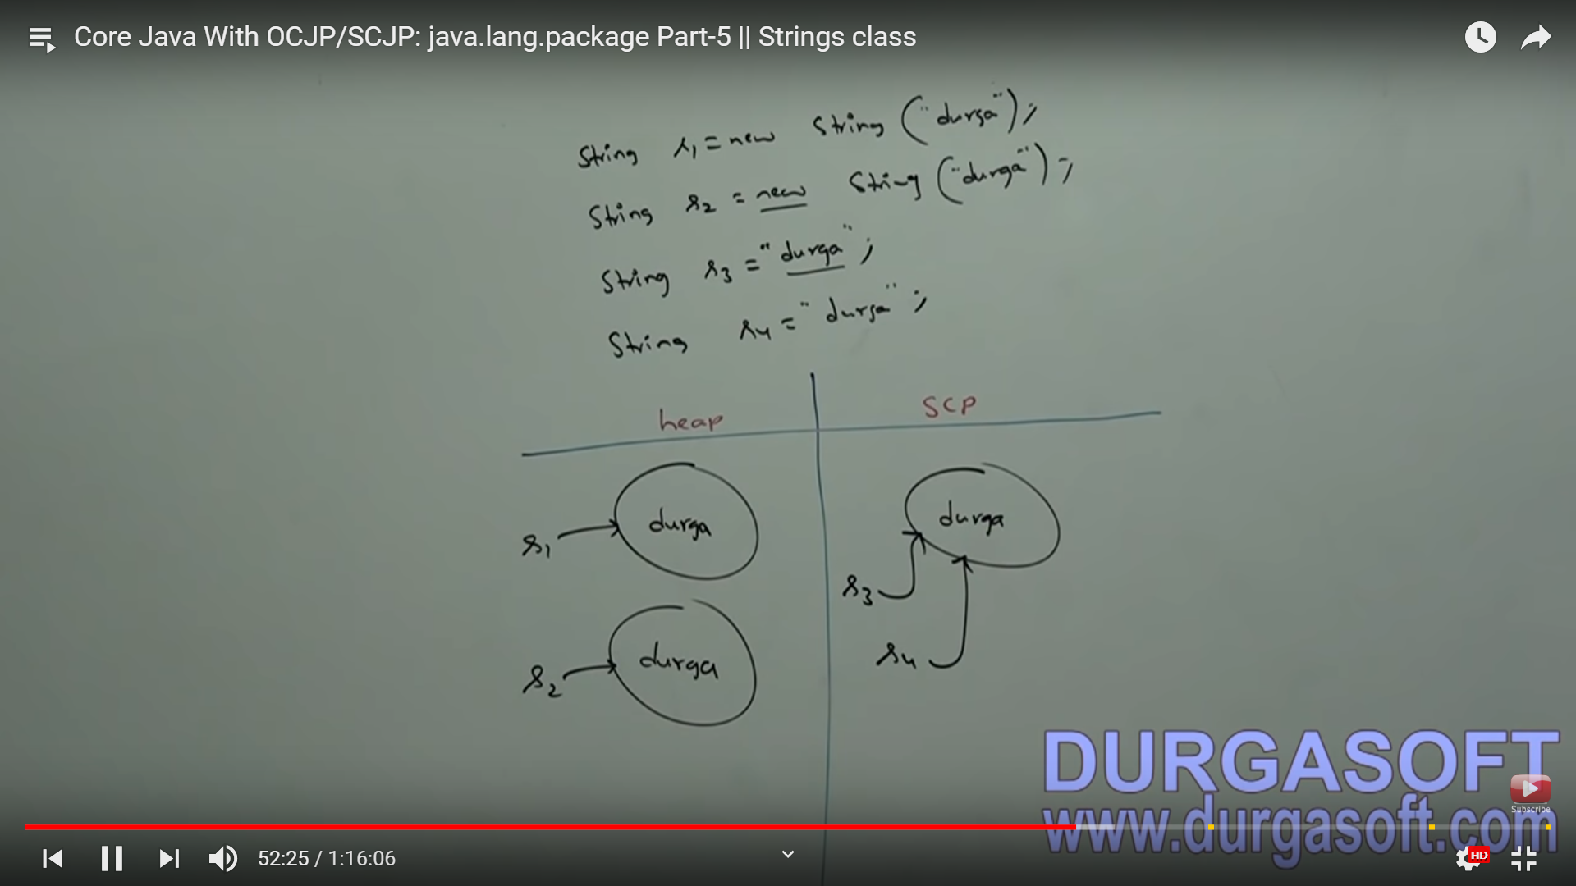

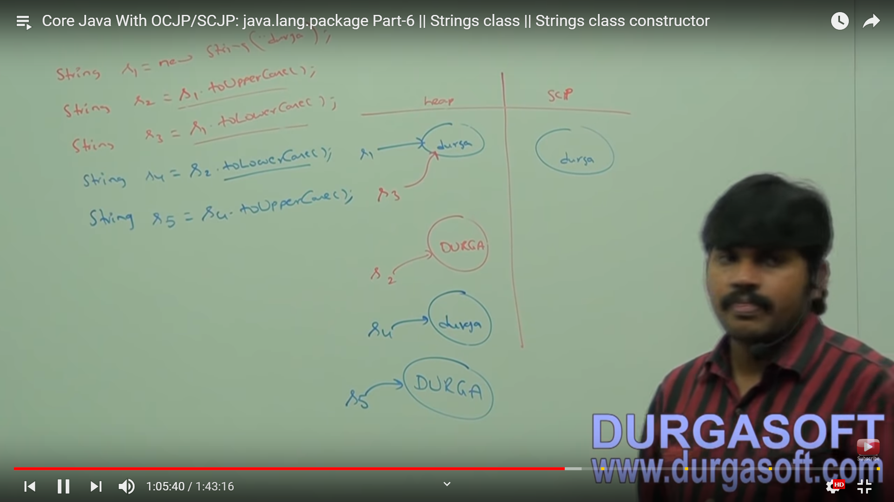

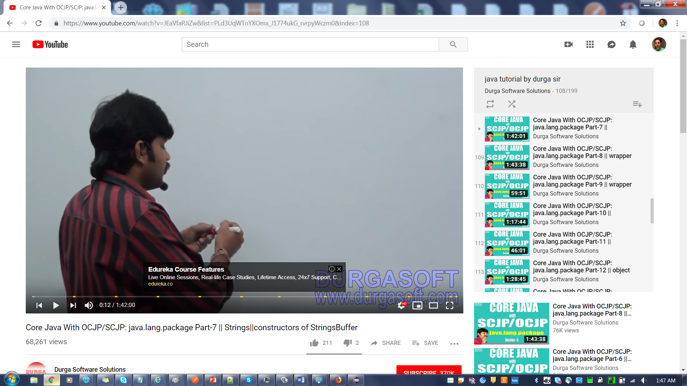

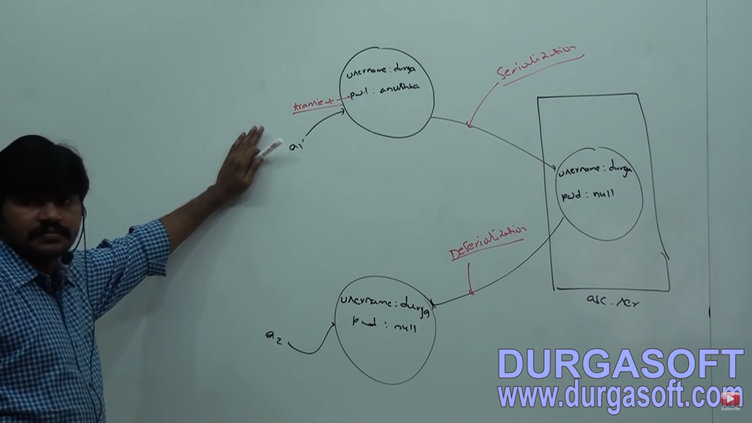

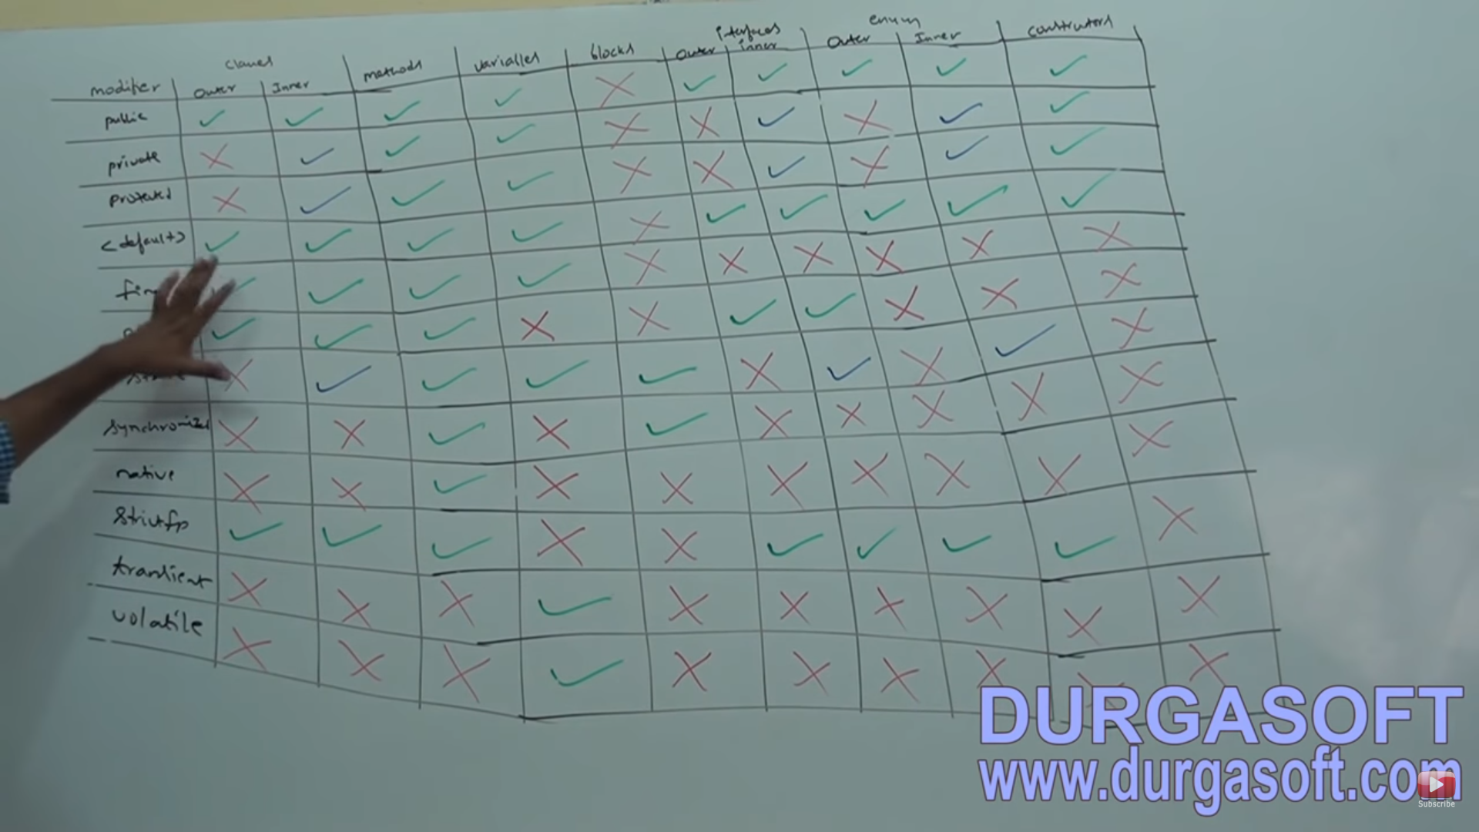

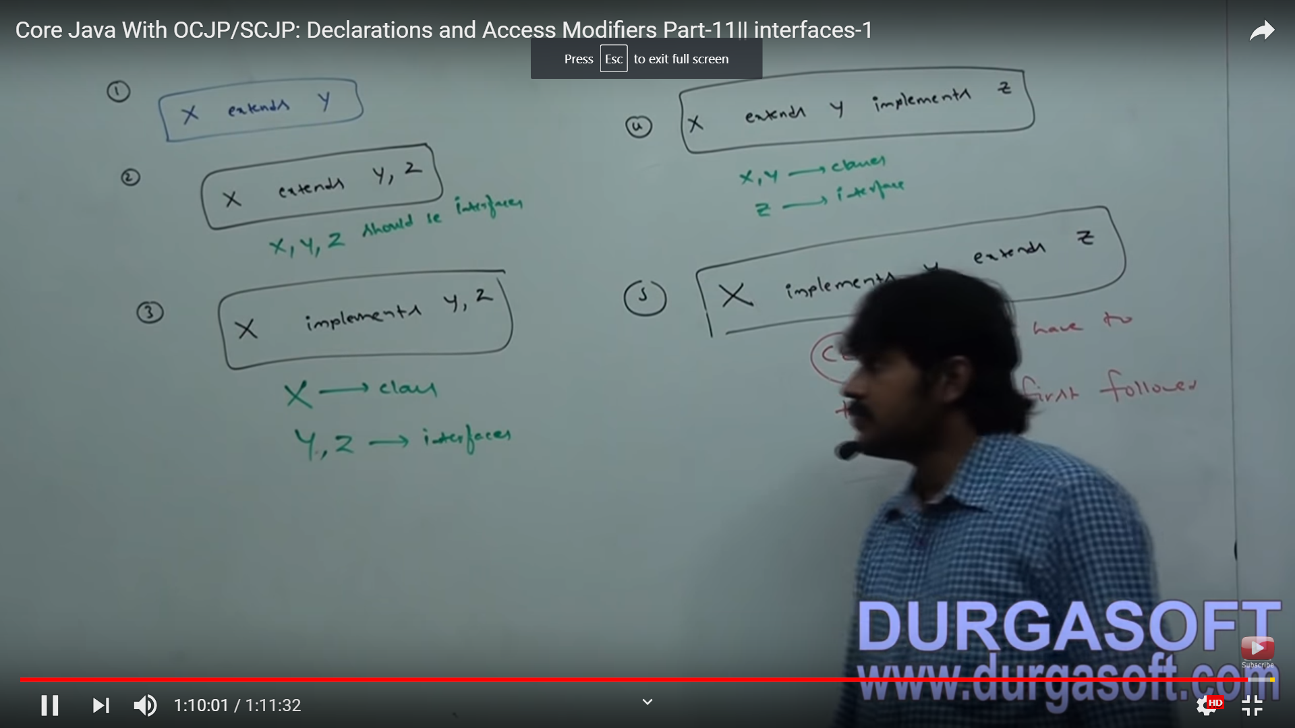

#################################WRAPPER CLASS ######################

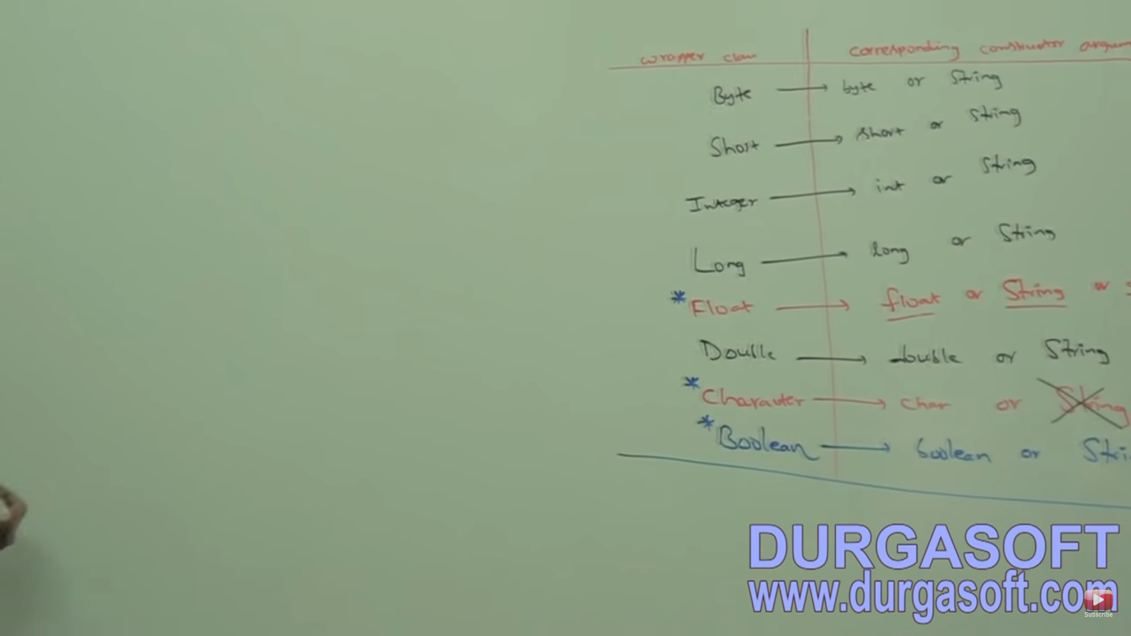

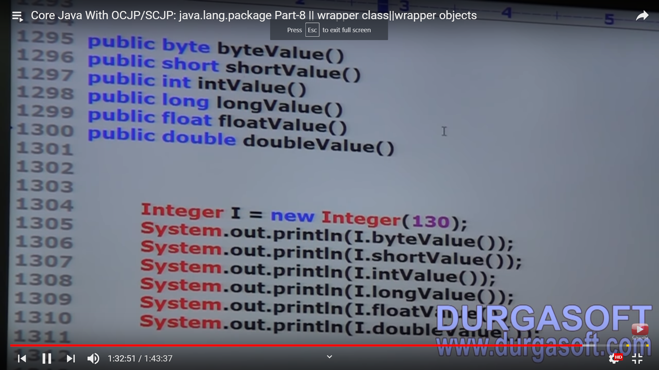

//*** Primitive value ------->Autoboxing(valueOf) ---------> WrapperObject

//##########################11th March 2019 #############################

Link : https://www.youtube.com/watch?v=tcHVFR5OzD8&index=11&list=PLd3UqWTnYXOlEa6-58nC6bnpx43VZiTnN

Autoboxing Important cases

// W--A // Not possible.

// Widening followed by Autoboxing is not allowed in Java.

// A-->W ---> Possible

// where as Autoboxing followed by Widening is allowed.

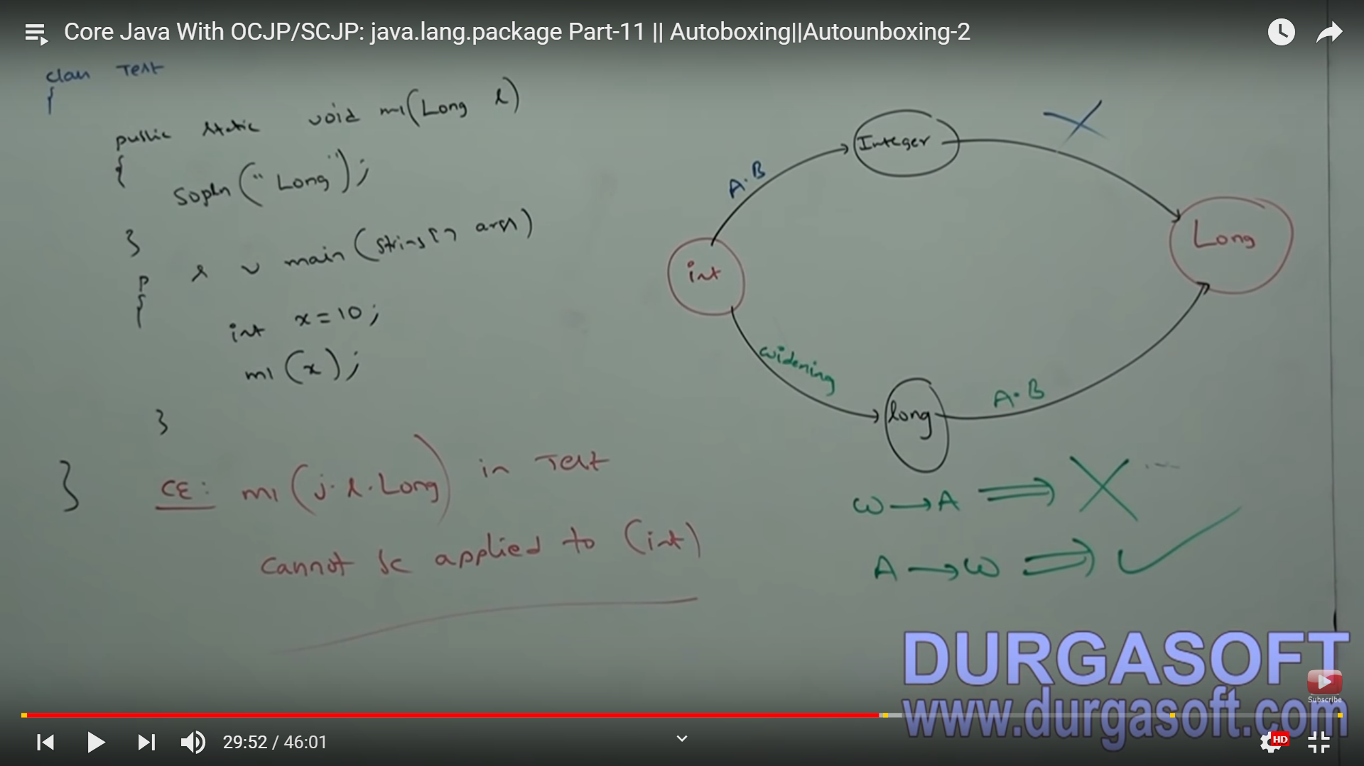

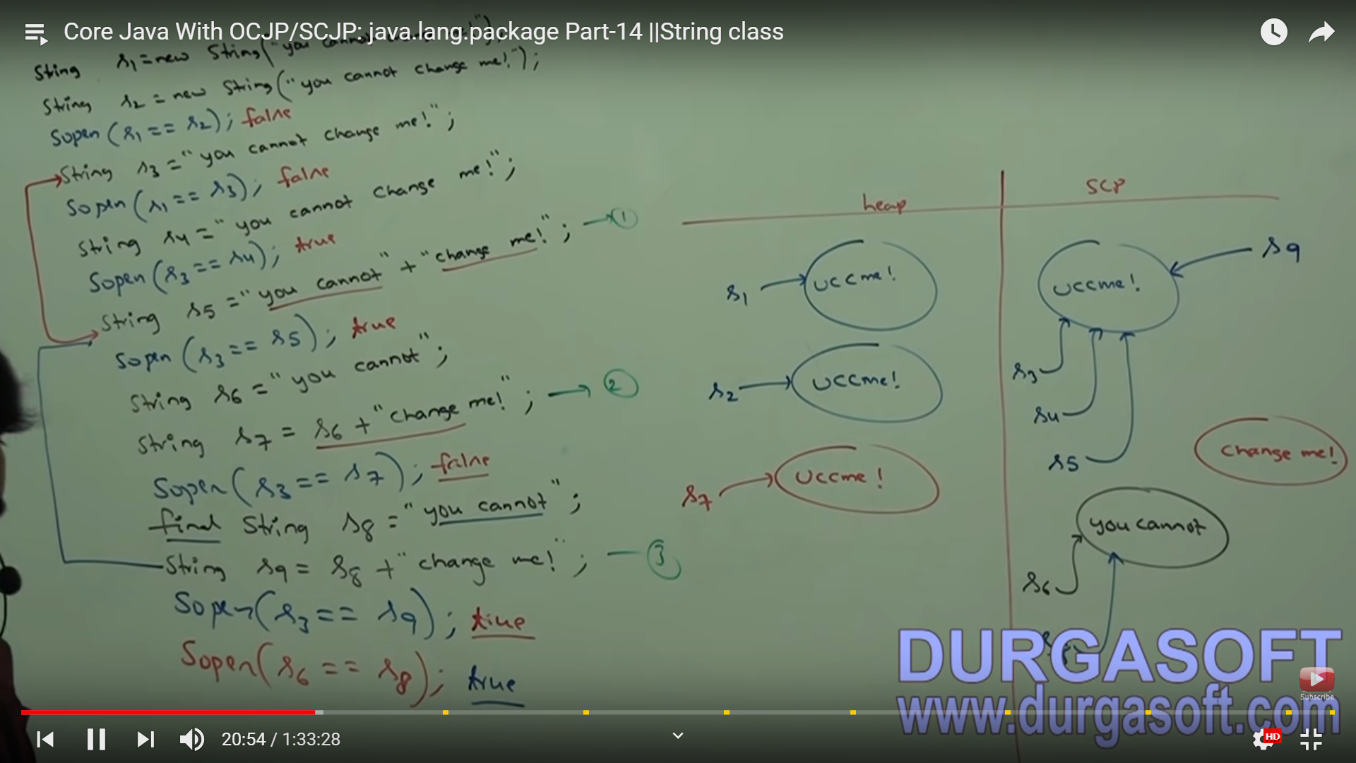

, constructors are never inherited. They aren't methods. They can't be overridden (because they aren't methods and only instance methods can be overridden). So the type of constructor(s) your superclass has in no way determines the type of default constructor you'll get

### static method can access a static method or variable

#### Overriding is for instance methods and Redefining or hiding is for Class methods. Redefining is only in case of Static methods as Static methods don't have a run time Polymorphism.

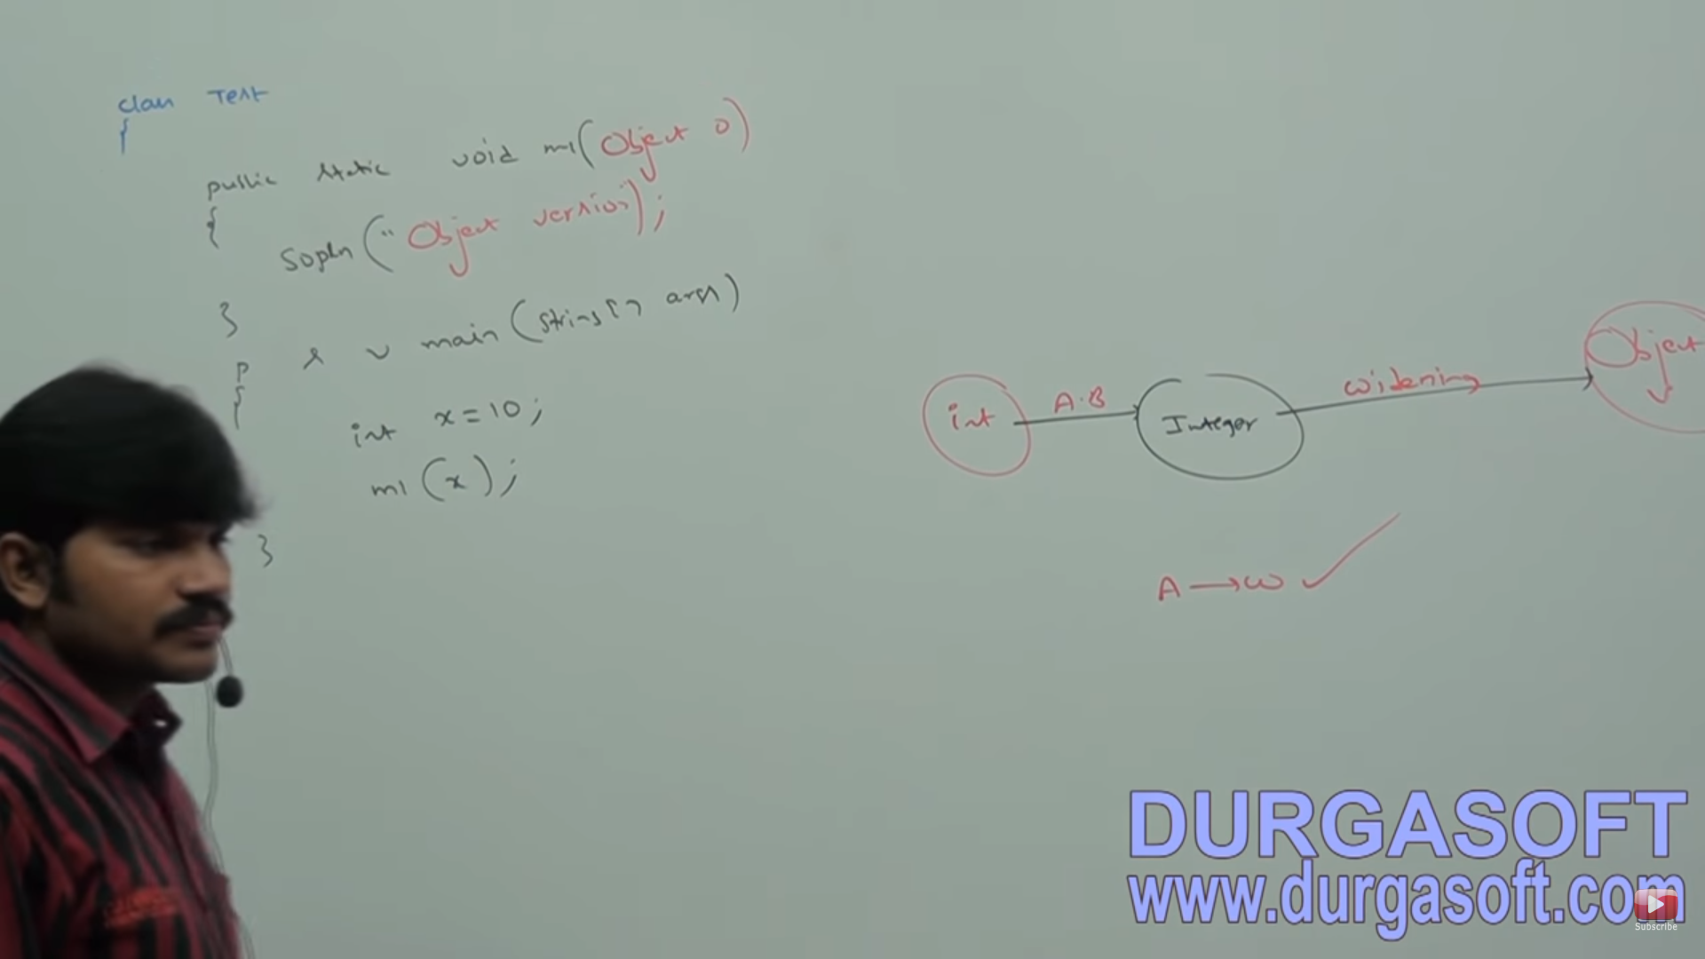

You can't mark a class as both abstract and final. They have nearly opposite meanings. An abstract class must be subclassed, whereas a final class must not be subclassed. If you see this combination of abstract and final modifiers, used for a class or method declaration, the code will not compile

You need to remember one key rule for interface constants. They must always be **public static final**

**The main purpose of constructor is to initialize the object i.e. to provide value for instant variables.**

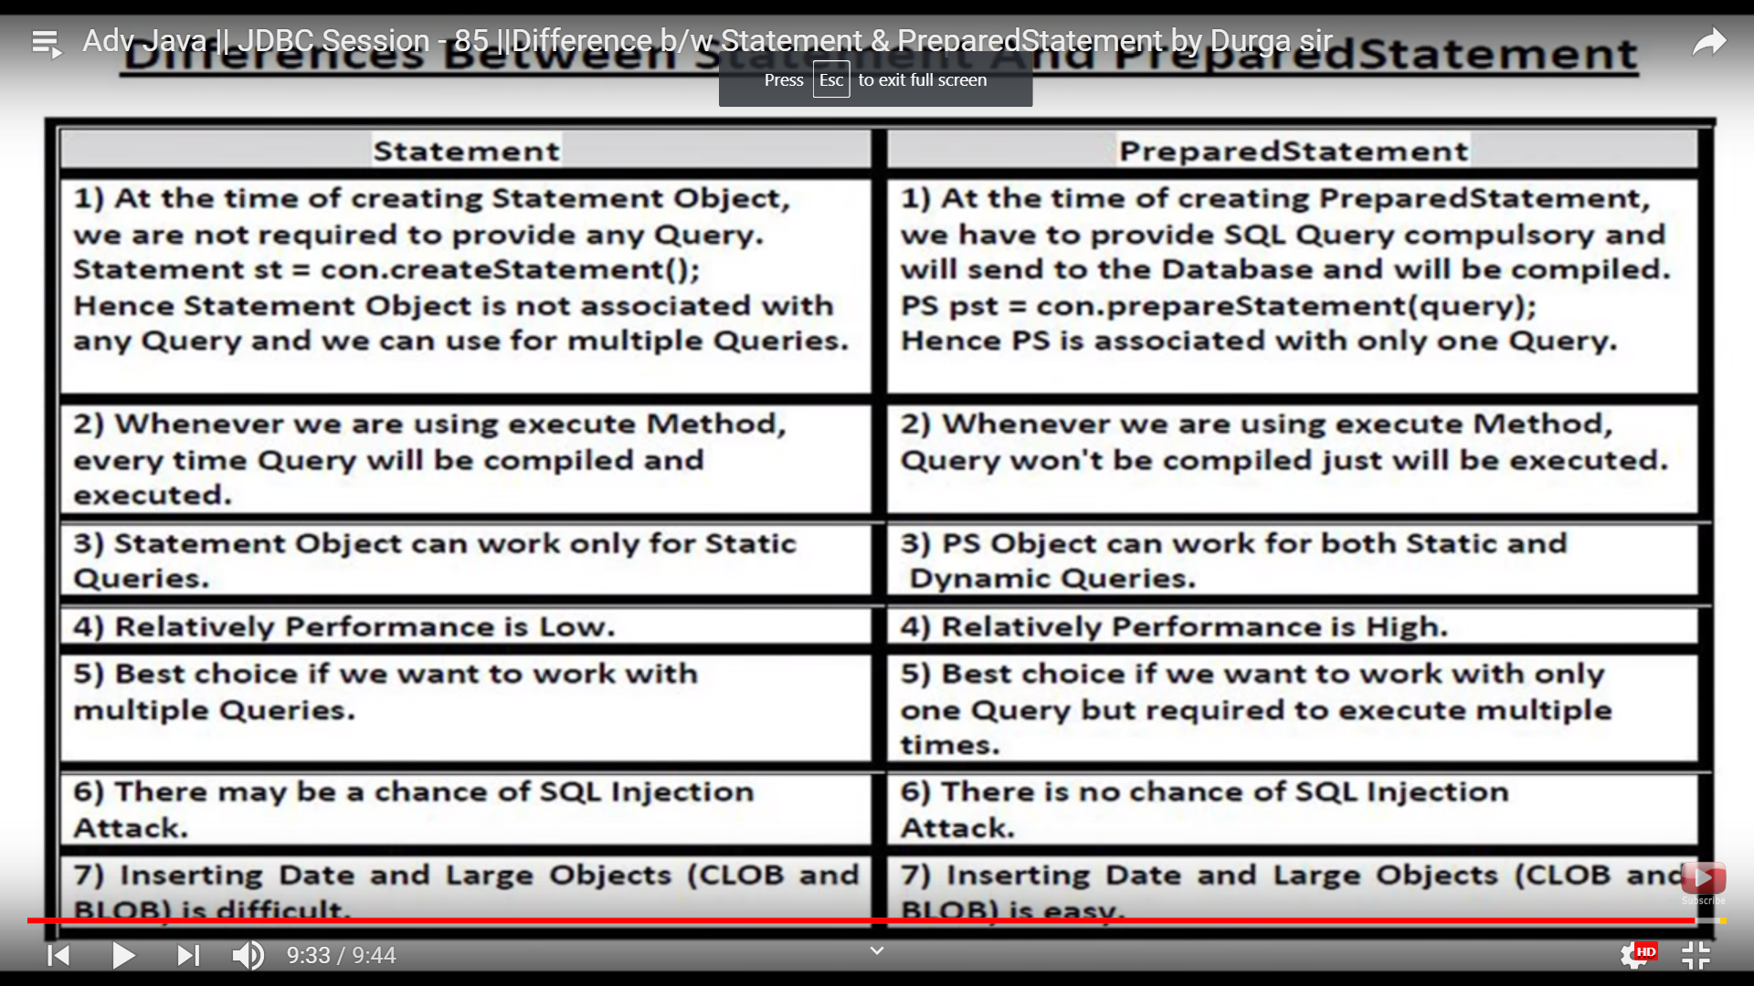

JAVA IO:

